Chapter I

  - PROJECT OVERVIEW

INTRODUCTION

We go over circumstances where people need to move cash quickly without going to bank or finding a trustworthy web related pc to use web banking. Mobile banking is attractive because it is a convenient approach to perform remote banking, but there are security shortfalls in the present mobile banking implementations We discusses some of these security shortfalls, such as security problems with GSM network, SMS/GPRS protocols and security problems with current banks mobile banking solutions and propose A secure system for electronic funds transfers that enables users to instantly move money between accounts. simply by providing account details. The system uses des encryption close by a second affirmation and consistency check computation for second secure electronic resource move. Clients could visit any EFT people group and pay through cash for second move inside 1minute using a singular card. This grants clients to securely move data without visiting a bank or finding a web related pc to login to a web banking account. The structure is to be used at genuine Electronic money move centers that can allow clients to channel their card and as they check they get a SMS message involving an OTP (when mystery express). Resulting to entering the right mystery express in the circumstance it allows the client to move holds. The client may now enter acc nuances of the client to sent portion close by portion aggregate. Our system by and by scrambles this data using DES computation preceding sending and sends it to our internet based laborer. The other client account is credit as necessary by ensuring its security using DES computation

The emergence of secure fund transfers over an internet using web application has significantly increased and going cashless where we need to maketransfer of money more securely. With DES algorithm each users data and their details whichare showing in this application are encrypted for data privacy and protections also doubly ended authentications enable of security key for fund transfer allow us to transfer money securely, each users are given with security key for each and every fund transfer with 5min of session time to enter security key. Once user or receiver exceed 5min session transfer of money get cancelled automatically to avoid accidently

The electronic funds transfer (EFT) industry traces its origins to the introduction of the first automated teller machine (ATM) in the mid-1960s. This innovation enabled users to perform banking transactions, such as deposits and withdrawals, using a standard magnetic stripe card and a personal identification number (PIN). With the rise and acceptance of ATMs, U.S. financial institutions began embracing EFT systems. EFT refers to the use of computer and telecommunications technology to facilitate electronic payments, rather than relying on cash or checks. It serves as a broad descriptor for various payment methods that utilize electronic systems for transactions.

Ensuring the highest level of security in electronic funds transfers is paramount. Therefore, a proposal for a final-year project focuses on prioritizing user safety. This initiative aims to develop a fraud prevention system for online financial transactions. Data encryption plays a crucial role in today’s interconnected world. The two key aspects of advanced data encryption are protecting information and ensuring its authenticity. As society becomes increasingly interconnected and more data becomes accessible, there is a growing need for safeguards that maintain data integrity and confidentiality.

In this final-year project focused on secure electronic funds transfers, the Data Encryption Standard (DES) algorithm is utilized alongside real-time verification and consistency checks to ensure safe transactions. To initiate a transfer, a customer simply needs to visit any EFT center and can complete the transaction quickly using a single convenient card. This system ensures secure transactions through DES encryption, allowing for immediate processing. Once the transaction is completed, the customer receives a confirmation Gmail message.

The mail notification includes a one-time password (OTP), enhancing the security of the transaction. Customers simply need to enter this OTP to proceed with their desired transaction. Before being transmitted over the network, this data is encrypted using the DES algorithm, ensuring secure electronic funds transfers.

This project aims to address the lack of encryption commonly found among banks and local processors, which poses significant risks. Without encryption, transmissions can be intercepted, altered, or even deleted, allowing attackers to redirect or cancel transactions. To mitigate these risks, implementing public key cryptography is recommended for proper authentication and security. This approach, along with necessary compensating controls, will help protect cryptographic keys and enhance overall system security.

PROJECT OBJECTIVE and SCOPE

Our project objectives is to lay out the refined and easy to understand computerization programming to carry out Secure electronic asset move over web utilizing des calculation which permits all client to make financial balance uninhibitedly and move the cash to another client, store collector and shops proprietors for installment safely with two sided validations, and furthermore information of every clients are encoded for security and insurances of information utilizing DES calculation. The goal of this project is to create a secure method for user transactions. By utilizing the Data Encryption Standard (DES), both transaction details and user account information can be effectively protected. Since the system operates online, there is no need for local installation; it can be accessed via the internet from any location.

During transactions, DES encryption safeguards user account information. Additionally, administrators have the capability to add new locations to the system, including details such as ATM machine IDs and passwords, as well as information about the ATM maintenance personnel.

The principal targets of the secure bank transfer project are as follows
- To make an online interface to safely move cash over web utilizing encryptions calculations (DES)
- To permit a client to enlist on this gateway and to make ledger openly for cash move.
- To make a protected gateway for all retailers for the installment for merchandise consequently through this application
- Giving the administrator to add all the bank subtleties including IFCS, Branch, MICR and other bank subtleties.
- To give Bank Director to endorsement the bank client account manifestations demand and empower them to move cash safely over web.
- To give clients to mentioning account manifestations
- To give clients to pay cash to retailers online with two sided validations process
- To give client to do online installments and fast exchange

  - Scope
Project planning, defining the project's scope is the most critical step. If we start the project without knowing what we need to deliver to the client and the project's boundaries, success is unlikely. In scope definition, elements inside and outside the project's boundaries are clearly identified to understand what the project will control. If we fail to properly define the project scope, managing it during execution becomes nearly impossible. Scope refers to a project's limits and determines what work will be completed during its lifecycle, including identifying tasks. During the arranging system, yields are made to catch and characterize the work that should be finished. The controlling and observing cycle is worried about overseeing extension. Reporting, following, and supporting/disliking project changes. At long last, the end processes incorporate a review of venture expectations and evaluate the results against the first arrangement.

Scope encompasses both product scope and project scope. Project scope includes business requirements, project requirements, and delivery requirements. Product scope covers technical requirements, security requirements, and performance requirements. The main purpose of scope definition is to clearly outline the boundaries of project.To characterize an undertaking extension, we should initially recognize the accompanying things:

- Project goals
- Objectives
- Sub-stages
- Errands
- Assets
- Spending plan
- Plan

5
Once element established, we must clarify the project's constraints or boundaries and to clearly identify aspects that will not be included. By specifying what is and isn't , should make it clear to stakeholders, senior management. This project is designed to explore and utilize the robust modern technologies of web development and implement the requirements within the project's scope.

Chapter II

RELATED WORK AND LITERATURE SURVEY

Conducting a literature review is first step in development of the software process. Prior to fostering the instrument, to decide the time component, economy and company capabilities. Once these aspects are fulfilled, the next steps involve determining which operating system and programming language will be used to develop the tool. As the software engineers begin building the tool, they will require substantial external support. support come from senior programmers, books, or websites. Before constructing the system, considerations taken to account for developing the proposed system.

The topics for literature reviews and related work are selected to support the project. The primary goal of a literature review is to establish a foundation for practical work and demonstrate that the student is familiar with existing research and literature on the topic. It is unwise to reinvent the wheel; one must accomplished. We have conducted a review on internet and app-based fund transfers, as well as web applications across different websites, and we have come regarding secure electronic fund transfers. One common issue we observed is the lack of security and protection for fund transfers.

Initially, we explored various resources on designing effective website front-ends, examining models that demonstrated functionality and applying these concepts to our project. We aimed to implement ideas to create the user interface (UI) for our project. We refined the design, making it more attractive and engaging with the help of web design best practices. Once the front-end UI was developed, we encountered some challenges in linking these fields to the database. To address this, we investigated the workings of backend modules, referring to resources and examples we found online. Most of the e-commerce sites we reviewed had certain limitations, which we are working to address in our project.

C. H. Meyer and S. M. Matyas (1981) examined personal verification processes across various institutions within an interchange environment, noting that these processes are typically distinct from one another. They propose that personal verification relies solely on information stored on the bank card and data memorized by the user. Their findings indicate that the necessary criteria for secure verification can only be met by utilizing a secret value stored on the bank card. By incorporating a personal key, a similar level of isolation can be achieved for authenticating transaction requests sent from the entry point to the processing systems.

Dan Zhu (2002) explored how contemporary financial institutions have capitalized on the internet's electronic business opportunities by creating a variety of payment systems to address diverse payment service needs. The paper reviews the functions and operational flow of the electronic funds transfer process, along with its security control mechanisms. It also introduces the Society for Worldwide Inter-bank Financial Telecommunications (SWIFT) as a standard inter-bank payment system to assess telecommunications and data security techniques. Additionally, several key security features are examined in detail.

Mintu Philip and Asha Das (2011) argue that chaotic encryption methods offer significant advantages over traditional encryption techniques currently in use. This approach represents a new frontier in cryptography, leveraging properties of chaotic systems, such as sensitivity to initial conditions and information loss. Over the past two decades, numerous chaos-based encryption methods have been introduced and analyzed. These methods aim for improved performance by harnessing the increasingly complex behavior of chaotic signals.

Mohammed Abudallah MdAysan, Fareed Hassan Almalki, and Abdullah Mohammed Almalki (2014) present a symmetric key cryptosystem that utilizes the mathematical logarithm function. This system takes advantage of the algebraic properties of logarithms, such as non-commutativity, high computational speed, and flexibility in key selection, which contribute to the security provided by the Discrete Logarithm Problem. Additionally, the encrypted text is converted into binary format to enhance its complexity and protect against unauthorized access. This method is applicable across various sectors, including businesses, government agencies, communication networks, defense systems, and sensor networks.

Gang Hu explores the field of cryptographic sciences in the paper titled "An Inquiry into Diverse Encryption Modalities." This work focuses on a thorough examination of current encryption techniques, presenting a comprehensive literature review. The primary aim is to conduct an extensive empirical analysis of various encryption implementations. The study places particular emphasis on image encryption, dual encryption, and methods based on chaos theory. Furthermore, it investigates the performance parameters that influence encryption processes while also addressing the associated security challenges.

In the paper "Computerization in the Banks of Baroda," Fei Shao, Zinan Chang, and Yi Zhang argue that the operational efficiency of financial institutions is closely linked to the effectiveness of their information systems for receiving, processing, evaluating, storing, and reviewing data. The authors assert that a well-designed and functional information system has yet to be fully realized and implemented. The increase in business activities has led to a significant workload at the branch level, creating imbalances and vulnerabilities that expose the institution to fraud. Chander suggests that automation at the branch level, along with systemic changes, is necessary to address these issues. However, it's important to note that the study does not consider the role of automated teller machines (ATMs), which represents a notable gap in its analysis.

In their paper "A Comparative Survey on Symmetric Key Encryption Techniques" (International Journal on Computer Science and Engineering, May 2012), Agrawal Monika and Mishra Pradeep provide a foundational overview of symmetric key encryption methods relevant to secure fund transfers. Their research offers a comprehensive examination of these techniques, highlighting their importance in maintaining the confidentiality and integrity of financial transactions.

Building on this foundation, XYZ conducted a study focused specifically on secure fund transfer mechanisms. This study emphasizes the critical role of symmetric key encryption in safeguarding financial transactions, while also addressing the practical implementations and challenges associated with using symmetric key cryptography in fund transfer processes.

CHAPTER III
SYSTEMS ANALYSIS AND DESIGN

Introduction to System Analysis
System involves a comprehensive examination of the various operations within a system and their interactions both internally and externally. The primary questions addressed in this process are: What issues are present in the current system? What actions are required to resolve these issues? Analysis begins when users or administrators review the program using the existing system. The effectiveness of the system is significantly influenced by how well the problem is defined, investigated, and addressed through appropriate solutions. A robust analysis that model clarify the problem but also outline a framework for the solution. Essential to thoroughly study the system by gathering relevant data.

  - Existing System:

the traditional fund transfer system which are embedded in current e-commerce website and banking system has many ways to transfer money through internet which are credit card based transfer, online internet banking mechanism, Direct deposited money transfer, and Wi-Fi based wireless transactions which are based on sender side authentication process which might sometime leads to accidental transfer of money to the wrong person, in other words if sender accidently enters unknown receiver person account details the transaction might get success.
Presently otp authentications methods are being used by banking server and management for verifications for genuine users and transactions. This method which leads to wrong transfer of money, to handle such cancelation of fund transfer and refund might take more than 48hrs of waiting time user.

Disadvantages:
    - While transferring money through cards if cards get jammed or broken user transfer of money will be cancelled
    - Refund and cancellation of fund transfer takes long time
    - One side authentication process

Proposed System

The Secure Electronic fund transfer over Internet is a web based application, viable with any internet browser with admittance to Web, providing online banking services for the customers of the bank and also ensures security, integrity and confidentiality of customer's activity and personal information from unauthorized access. The system also provides interface for the internal users and system manager of the bank to process all the customer transactions and requests. Individual clients, vendors, framework directors and framework overseers can utilize this application. Each type of user has specific functionalities and corresponding interfaces designed to perform those functions. Two side authentication protocol is used for secure transaction and encryption of data transmitted between user and merchants are also maintained for data security. A two-factor authentication is setup for individual users to sign into the application. First factor is by supplying username, password and second factor is using One Time Password (OTP).

An additional layer of security is to be provided to customers to perform critical transactions using challenge response validation utilizing public key foundation (PKI).every transactions is that sender makes are generating a unique secure key which is sent to both sender and receiver for secure transaction over internet within 5 min session time.

Feasibility Analysis

A feasibility study is a crucial step in the requirements engineering process. It involves assessing whether the identified user needs can be met using current software and hardware technologies. This evaluation determines if the proposed system is viable and if it can be developed within the existing financial constraints. The feasibility study should be relatively cost-effective and conducted quickly. The outcome of this study should guide the decision on whether to proceed with a more detailed analysis.
A feasibility analysis is conducted to select the system that best meets performance requirements, primarily focusing on cost. In product design, I concentrated on three key areas. The main considerations in a feasibility analysis are:

- Operational Feasibility
- Technical Feasibility
- Economic Feasibility

Operational Feasibility Study: The proposed project is valuable because it can be developed into an information system that will fulfill the organization's operational requirements. The product will be created without ongoing examination of specific processes within any organization. Their performance-related issues not currently addressed during the development phase, considering the efforts and costs involved.

Technical Feasibility Study: Technical feasibility assesses the existing computer system and its ability that support proposed system. The current computer is operating at 80% capacity, adding a new application might overload the system or necessitate additional hardware.

Economic Feasibility Study: Economic feasibility, often referred to as cost-benefit analysis, is a common method for evaluating the viability of a mobile client system. This approach involves assessing the anticipated benefits and savings from the mobile system and comparing them to the associated costs. The analysis aims to determine whether the benefits outweigh the expenses. Additionally, the application is designed to be user-friendly.

Chapter IV

SYSTEM SPECIFICATION ANALYSIS

Introduction to Requirement Specification analysis

The Software Requirements Specification (SRS) is the initial phase in the development process. It includes an introduction that outlines the purpose, scope, and overview of the system. This involves gathering requirements by engaging with stakeholders and understanding their needs. The SRS provides a general description of the product's features, functionality, and user characteristics. It also details the overall functional requirements, performance standards, and design constraints. Essentially, the SRS translates the conceptual ideas of the users (input) into a structured document (output phase). Product Specification report is organized to facilitate validation and system design.

System Requirements Specification

The Software Requirements Specifications document captured the needs of the end users and communicates them to the development team. The requirements document includes both functional and non-functional specifications. Below is a summary of the requirements:
Functional requirements: Functional requirements outline the essential tasks that the system must execute.
- User Registration: All client can enroll to secure transfer applications however
- administrator are approvers. Enrollment contains email-id, Password, name, telephone no., city, address subtleties, orientation, DOB, ethnicity and needed for authenticity of users. Approved customers can have logged to dashboard, with registered id and password (Secure key) and can request a new one via email notification or by contacting the administrator.
- Add / Delete Bank Details: Add / delete bank details option to add and erase the subtleties of the bank and its branches in and around urban communities to the database which is displayed at different pages
- Account Creations Request: Account create options is enabled in user module which
- provided to users to choose the desired bank and branch to create bank account for secure transfer of money
- Approval and Create Account: this component is allowing the Bank Managers verify upload documents of customers and to create the account for users who uploaded all the
genuine documents which are saved to the database and displayed at bank manager modules and user module pages
- Add initial amount: Feature provided to bank manager to add initial deposit of amount to the account holders
- Refund details: This Options is provided for bank manager for cancellations of money transfer which are requested by the various users.
- Quick Transfer: Quick transfer is the main component as it provides a to users for quick transfer of money to users(beneficiary users) securely with security key and 5min of session.
- Online Payment: this option is used by the customers to pay the money to shop owners securely
- Non Functional requirements: Non-functional requirements specify the needs related to performance, logical database constraints, design limitations, adherence to standards, reliability, availability, security, and maintainability.
- Proficiency:it refers to high skill or competence in a particular area or activity. It indicates the ability to perform tasks effectively and accurately due to extensive knowledge, experience, or training. For example, proficiency in a programming language means having the expertise to write, understand, and troubleshoot code effectively.,
- Security: The system is accessible only to authorized users, ensuring robust protection for user data. Unauthorized individuals cannot modify the information within the system. User data is kept confidential and will not to share to any third parties. If an unauthorized attempt is made to system, an automatic notification is sents to administrator.
- Reliability: The online interface is expected to be dependable to daily use, a crucial factor.
- Practicality: Maintenance should be minimal, as the system is designed for continuous operation. Therefore, prolonged maintenance times are unacceptable.
- Convenience: The system will be available at all times for viewing information or accessing
- other features it offers.

Hardware Requirement Specification

Processor | Intel i3 Core or higher
Processor speed | 1.70GHz - 2.40 GHz
RAM | 4 GB
HDD Disk | 100GB

Software Requirement Analysis

The project will be developed in a XAMPP (Linux, Apache, MySQL, PHP) or WAMP (Windows, Apache, MySQL, PHP) environment. A robust content management framework MVC architecture will serve as the platform building for proposed system.

Server Running Environment:

OS | Windows 7/8/10/11
Web Server | Apache
Programming Language | PHP 5 and above
Database | MYSQL

Development Environment:

Front End | HTML 5, CSS3, Bootstrap
Web Server | Apache
Programming Language | PHP 5 and above
Database | MYSQL
Client | Google Chrome or any web browser

Chapter V

SYSTEM DESIGN

Introduction to System Design

Design is a critical phase in transitioning from identifying issues to developing solutions. It serves as the bridge between requirement, specification and final implementation. The aim to create model the system, which will later to construct the actual system. This model referred as the "System Design" and provides a structured solution for the system. design is both most creative , challenging part of development lifecycle. It involves creating the framework for the proposed system, which guides the coding process. This phase includes understanding and detailing the necessary procedural elements for implementation. It also involves identifying various subsystems that together form the complete system. During this stage, data organization and output formats are discussed and designed. The system design consists of multiple steps, with a focus on translating performance requirements into detailed design specifications.

Input Design

In the information plan, client began inputs are altered over into a PC based framework design. It likewise incorporates deciding the record media, technique for input, speed of catch and passage on to the screen. Online information section acknowledges orders and information through a console. The significant way to deal with input plan is the menu and the brief plan. In every other option, the client's choices are predefined. The information stream chart demonstrates legitimate information stream, information stores, source and objective. Input information are gathered and coordinated into a gathering of comparable information once recognized input media are chosen for handling.

In this product, significance is given to foster Graphical UI (GUI), which significantly consider creating effective and easy to operate programming. For contributing client information, alluring structures are planned. Client can likewise choose the ideal choices from the menu, which gives generally potential offices. Likewise, the significant information design is planned so that inadvertent mistakes are stayed away from. The customers need to fill just barely the base information required, which additionally helps in keeping away from the mistakes that the clients might make. Exact information design is vital in creating proficient programming.

Result Design
The accentuation is on creating a printed copy data mentioned or foreordained configuration. Two most result media today are printers and the screen. Most clients presently access reports from either a printed copy or screen show. the primary and most Effective and consistent output design should enhance the system' interactions with user, assist in decision- making.

Requirement Analysis and Specification:

A primary objective to stage is to understand the user's specific needs and accurately document them.
    - Prerequisite Assortment: We gathered the necessity from Spritz Intuitive Advances Ltd., Bangalore .
    - Plan: The goal of configuration stage is changing the prerequisites determined report to a design for reasonable for execution in some programming language. In specialized terms, during the plan stage the product engineering is gotten from SRS record. We need to plan this undertaking utilizing HTML and CSS.
    - Coding and Execution: When configuration is finished, goal that stage to decipher plan the framework . For a given plan, the point in this stage is to execute the plan in the most ideal way. We have coded the plan utilizing PHP, Java Content and Java Question and we even utilized Bootstrap to foster the undertaking.
    - Testing: Testing is a crucial quality control measures used In the during software development. primary purpose to identify errors in software.

Maintenance:
      - Corrective Maintenance: Addressing errors not identified during the initial development phase.
      - Perfective Maintenance: Enhancing system performance and functionality based on user requirements.

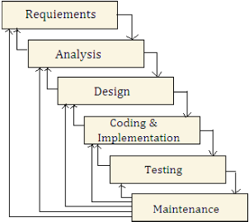

Fig: 5.1 Iterative Waterfall Model

  - Architecture Design

Architecture Design refers to the applied plan and key functional structure of a system. It provides an overview of project, as illustrated in the diagram. Modern web application architecture often employs a three-tiered model based on a client-server structure. This model distributes system processing across client machines in the presentation layer. The presentation layer handles all user interactions, processes user input, sends requests to the server, and displays the results to the user. The application layer manages web processing tasks, handling all incoming requests, but does not store the processed data itself. For data storage, it interacts with the database server. The database layer consists of the database management system that oversees all persistent data.

The description accurately represents the architecture of Smart Desk. It aligns with the standard three-tier architecture, where MySQL constitutes the database layer, Apache and PHP services form the application layer, and users' web browsers represent the presentation layer. The WAMP (Windows, Apache, MySQL, PHP/Perl/Python) open-source bundle has been carefully assembled to fit the three-tier architecture, eliminating the need to manage each system component separately.

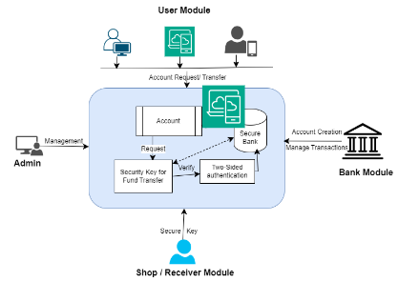

Fig: 5.2 Architecture Design

  - Module Specification

- Admin Module
- Bank Manager Module
- User Module
- Fund Receiver Module

Admin Module:

- Activating and Deactivating Owner: All the owners who gets registers has to be activated to ensure security to usage of this applications and also fake Owners has to be removed or deactivate through this module.
- Feedback Response: the messages and comments posted by both registered users and unregistered used are viewed and quick response is posted or mailed in this module.
- Add Bank Details: enable administrator to update bank details.
- View Banking Details: Administrator can verify the bank details by viewing the details of bank which are registered in this applications

- Banking module: It manages the following functionality:

- Registrations: Bank Manager registration process is done by admin while admin adds the bank details to the portal. The registered bank manager can then provide valid user id and password to login and to carry out other functionality.
- View Users: Bank Manager can view the user who are customers of the respective branch through this view user features. Also user are wanted to create account data are available to the bank manager to view.
- Approval User and Create Account: User who have requested to create bank account need to be created by bank manager by viewing the details and verifying the documents shared by the user. this features allow bank manager to approval user who have submitted valid documents to create account in the respective branch. Also this feature allows bank manager to create unique account number to user.
- Add Initial amount to the account: User who have requested to create bank account need to be created by bank manager and once the account is created bank manager need to update the initial amount deposited by the user in their respective account. This functionality is used to update initial amount deposited by the user by bank manager.
- View Complaints and Refund: User can transfer the money to other user once the account is created, while transferring the amount if user failed to secure transfer money to their beneficiary account. User allowed to raise complaints and request for refund. This features allow bank manager to view request for refund and view complaints of the users.
- View Failed Transfer: User transfer may sometimes get failed due to technical issue and network issues such failed transfer details need to be rectify by the bank manager this feature allow bank manager to view failed transfer
This module allows the Banking Management process user request and activity all the account holders to transfer money, it also allows Banking Management to user complaints and failed transfer details, and refund and or cancellation of fund transfer are maintained by this module.

- User module: This module in designed and build for users for secure electronic fund transfer using both side authentication process, requested transfer can process only once sender and receiver enters the valid otp. Users can also complaint for failed transfer or can put for refund and cancellation of transfer through this module
    - Registrations: User Needs to register to the portal to create bank account and use secure electronic fund transfer. This functionality allows all the user to register to the portal by providing their basic information’s to the portal. User data which are valid (pan number, Aadhar card number) are allowed to use the secure transfer features.
    - Request Account Opening: User after registration need to select a bank and need to create bank account to use the secure transfer feature. To create account users, need to fill up bank account opening form and submit requested valid document to bank manager. This feature allows all the user to request account opening to bank manager
- Money transactions: User after creating bank account and once deposited with initial amount need can start transferring money to beneficiary account. This feature allows to view money transaction carried out by individual users.
- File a complaint: User after using secure fund transfer option sometime me face failed transactions due to technical failure and network issue. Such failed transaction has to be sent complaint to bank manager to rectify the issue.
- Refund request: Once the complaint is raise for failed transaction user need to request for refund to the bank manager. This functionality allows the user to request for refund from the bank manager that can be rectified later.
    - View Transactions Summary: User after creating bank account and once deposited with initial amount need can start transferring money to beneficiary account. This feature allows to view money transaction summary and history.
- Quick Payment: This functionality allows the user to perform quick payment to the beneficiary account with simple and few clicks. This allows user to transfer money from one account to another account with secure and 2 side authentication.
- Online Payment: This functionality allows the user to perform online payment to the beneficiary account with simple and few clicks. This allows user to transfer money from one account to another account with secure and 2 side authentication.

- Fund Receiver module: This module in designed and build for Fund receiver users for secure receiving money, here merchants, seller can register and upload their details of their business, and receive the money from the users
- Registrations: fund receiver Needs to register to the portal to create bank account and use secure electronic fund transfer. This functionality allows all the fund receiver to register to the portal by providing their basic information’s to the portal. Fund receiver data which are valid (pan number, Aadhar card number) are allowed to use the secure transfer features.
- View Transactions request: Fund receiver can view the transaction requested by the user and allow the fund receiver to complete the transaction by providing secure number. This functionality allows user to view transaction request
- OTP Authentication Entry: User who are sending fund to fund receiver need to entry secure otp(number) to complete the transactions this features allows fund receiver to enter opt(secure number) and valid the same.
- View Transactions Summary: User who send the fund to the fund receiver need to be checked by the fund receiver for transactions authentications. This features allows the fund receiver to check for the transactions summary carried out on his account number.
:
  - Data Flow Diagrams

The data flow diagram (DFD) is a crucial modeling tool used to represent the components of a system. It illustrates system processes, external entities that interact with the system, data usage, and the flow of information within the system. DFDs show how data moves through the system and how it is transformed through a series of processes. This graphical method depicts data flow, illustrating how information progresses from input to output. Also known as a bubble diagram, DFDs can represent the system at various levels of abstraction and can be broken down into levels that detail increasing complexity and functional specifics.

Advantages:
- Clients effectively figure out these straightforward documentations.

- Clients can make ideas for changes.

- To survey the general framework late, they utilize the more significant level outline charts

.

Constructing of the Data flow diagram consists of
- Arrow
- Circles
- Component Box or Open End Box
- Square Box

An arrow represents the flow of data within the system, acting similar to how a box functions in a flowchart. A circle signifies a information. A open-ended boxs indicates a data stored, a repository of static data, storage of information. A square denotes a source or destination of system data.
Six standards for developing an Information Stream Chart

- Arrows should not intersect.
- Squares, circles, and records must be labeled.
- Decomposed data flow squares and circles may have identical names.
- Use descriptive names for data flows.
- Position all data flows around the perimeter of the diagram.

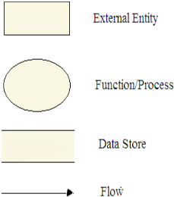

Fig 5.3 DFDs components

- Function Symbol: A function symbol is represented by rectangle or circle. This symbol, known as "Process," indicates a function or operation within the system.

- Data Store: An open rectangle or square symbolizes a data store. This represents a repository where data is kept, typically used for transactions and data manipulation.

- External Entity Symbol: A rectangle represents an external entity. These external components that interact with the system by supplying input or receiving output from it.

Context Data Flow Diagram

It is common practice to start with context-level diagram, which illustrates the interactions between the system and external entities that act as data sources and destinations. The context diagram, also known as a Level 0 DFD, presents the system as single processs and depicts its interactions with outside world solely in terms of data across system boundaries. This context diagram serves as the foundation for creating Level 1 DFD, which provides a more detailed views of the system's internal processes and data flows.
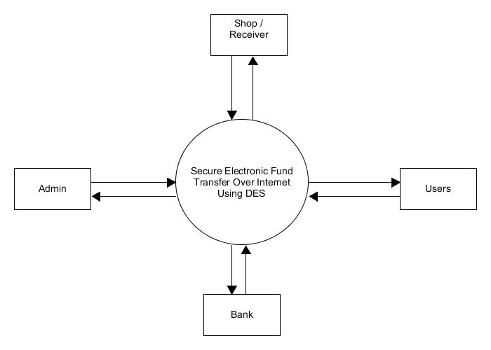

Fig: Context flow diagram

5.10 Data flow Diagram illustrations of each modules

Secure electronic fund transfer has following modules
- Admin Module
- Bank Manager Module
- User Module
- Fund Receiver module

5.10.1 Level I: Admin

The Level 1 DFD illustrates how the system is divided into sub-systems or processes, each handling one or more data flows to or from external entities. Level 1 Data Flow Diagrams (DFDs) provide a more detailed view of a system compared to Level 0 DFDs. They break down the main process into its sub-processes, showing how data flows between them and how they interact with external entities. These sub-systems collectively provide the complete functionality of the system. It also identifies internal data storage required by the system to operate effectively and depicts the flow of information between various components of the system. The given below DFDs gives the descriptions of data flow in the admin module. This DFDs helps us to understand the flow of data in each pages in the portal and gives the details of tables and data stored.

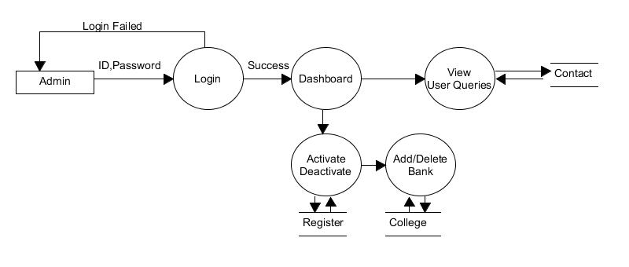

Fig: Admin DFD

5.10.2 Level I1: Bank Manager DFD
Level 2 Data Flow Diagrams (DFDs) provide an even more detailed breakdown of the sub-processes identified in a Level 1 DFD. They further decompose individual processes into smaller components, allowing for a comprehensive understanding of the data flow within the system. This level follows the Level 1 DFD and provides a more detailed view of data flow from sub-systems to additional sub-systems, showing how data is processed and stored within the database. The Level 2 DFD, as depicted below, elaborates on the information flow within these sub-systems.
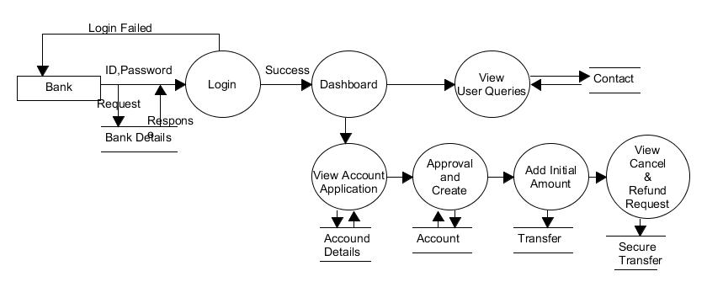 Fig: Bank Manager DFDs

5.10.3 Level 1II: User

The Level 3 DFD provides a detailed view of how the system is divided into further sub-systems or processes, each managing more granular data flows to and from the final DFDs. Level 3 Data Flow Diagrams (DFDs) provide an even deeper level of detail by breaking down the sub-processes defined in a Level 2 DFD into their individual tasks or operations. This level is often referred to as "functional decomposition" and is useful for capturing specific actions, decision points, and data transformations.

It illustrates the detailed flow of information within the system, showing how data is handled and processed in the final sub-systems. The Level 3 DFD, as depicted below, focuses on the client module and demonstrates the final stages of data flow within the system.

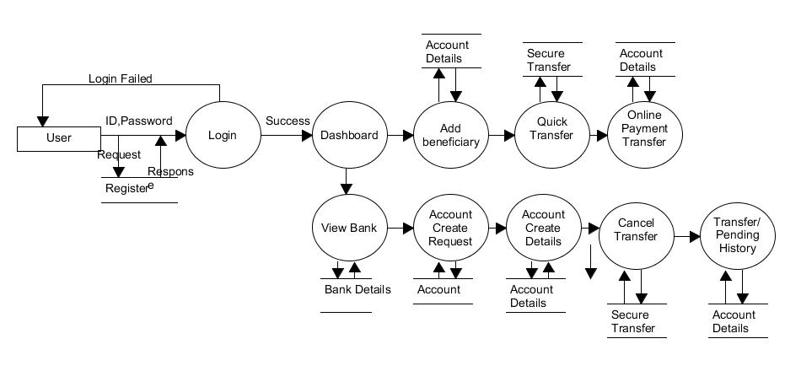

Fig: User DFDs

5.10.4 Level 1V: Receiver / Shop

The Level 4 DFD details the further breakdown of the system into additional sub-systems or processes, each managing increasingly detailed data flows to and from the final DFDs. This level expands on the data flow, showing how information progresses through its final stages and is handled by the last set of sub-systems. In our system, the Level 4 DFD, illustrated below, focuses on the client module and represents the most granular level of data flow.

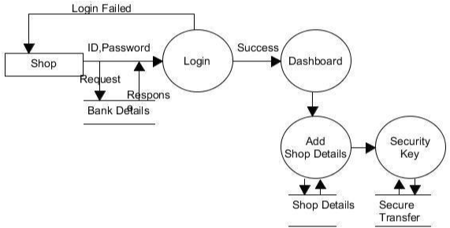

Fig: 5.8 Receiver /Shop DFDs

User Case

A use case diagram in the Unified Modeling Language (UML) is a type of behavioral diagram derived from use case analysis. It visually represents the functionality provided by a system in relation to actors, their goals (represented as use cases), and any conditions associated with those use cases.
A use case is a detailed narrative that describes how a user interacts with a system to accomplish a specific task or goal. It serves as a valuable tool in systems analysis and design, providing insights into user requirements and system functionality from the perspective of the end user. The primary purpose of a use case diagram is to illustrate which system functionalities are available to each actor. While it outlines the roles of actors within the system, it does not depict interactions between actors. If these interactions are crucial for understanding the desired system behavior, it may be necessary to reassess the system or use case boundaries. Alternatively, actor interactions can be incorporated into the assumptions or context of the use case.

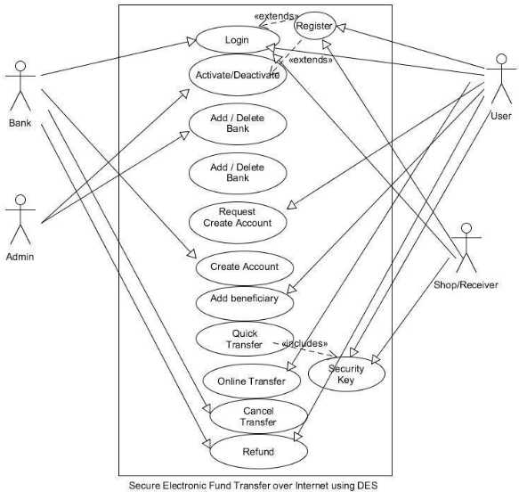

Fig: Use-Case

Interaction Diagram

A sequence diagram in Unified Modeling Language (UML) it illustrates processes or objects interact and the order in which these interactions occur. It is derived from a message interaction diagram. A sequence diagram displays various processes or objects as vertical lifelines and the messages exchanged between them as horizontal arrows, arranged in the order they are sent. This format allows for a clear graphical representation of straightforward runtime scenarios.

Database Descriptions

These projects involve dynamic updates and maintained database, project contains following tables
- Account
- Account Details1
- Account Details 2
- Account Details 3
- Bank
- Account Document Details
- Bneficiary Details
- Contact
- InitailAccount
- Registrations
- SecureTransfer
- shopDetails

Table underneath contains the Contact subtleties. This table goes under Administrator Module

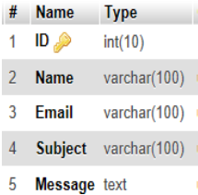

Table underneath contains the Record details1. This table goes under Bank Module

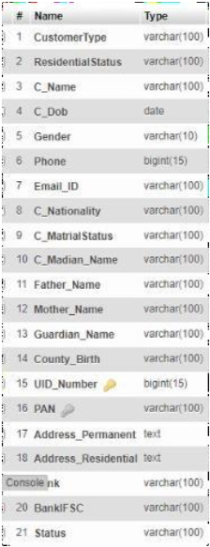

Information Table underneath contains Record Subtleties 2. This table goes under both Bank Chief Module
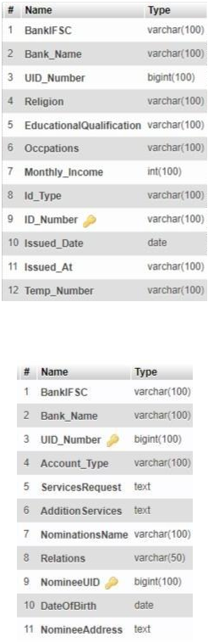

Table beneath contains the Record Subtleties 3 subtleties. This table is utilized by Bank Manger

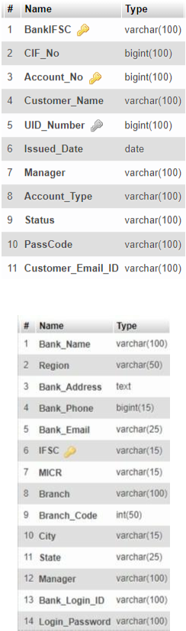
Information Table underneath holds Record Table. The table goes under Client Modules

Information Table beneath contains Bank Subtleties. This table goes under Client Modules

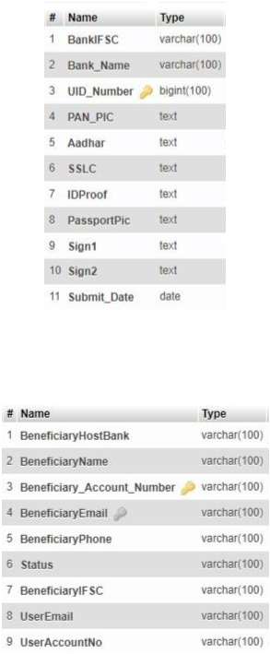
Information Table beneath contains Record Archive Subtleties. This table goes under the Client Module and Bank Chief

Information Table beneath contains Recipient Subtleties Experimental outcome . This table comes Client module

Information Table underneath contains Starting Sum Subtleties Experimental outcome . This table comes Client module

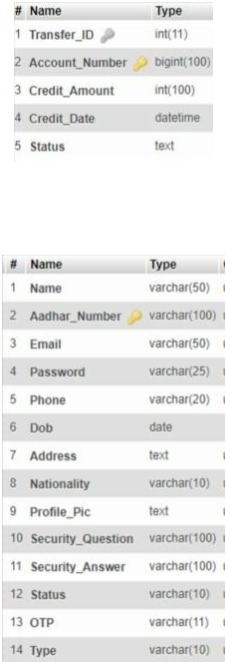

Information Table beneath contains Client Enlistments Subtleties. This table comes Client module

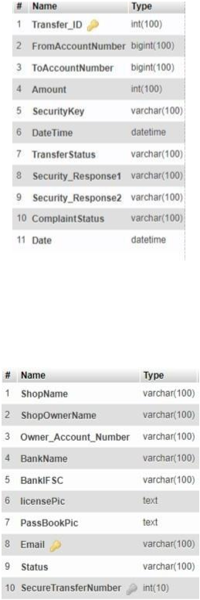
Information Table underneath contains Client Secure Exchange Subtleties. This table comes Client module and Bank Administrator Modules

Information Table underneath contains shop Subtleties. This table comes Client module and Administrator Modules

E-R Diagram

ER diagram is a specialized visual representation that illustrates the relationships between entities within a database. ER diagrams commonly use symbols to represent three distinct types of data. These diagrams employ a standardized set of symbols to depict each type of data and then establish the connections between them.

The Entity-Relationship (ER) model was developed to provide a clear and straightforward way to represent the structure and logic of databases. Over time, it has evolved into various forms, including the Enhanced ER Model and the Object-Relational Model.

The ER model focuses on identifying the entities that will be represented in a database and how these entities interact with one another. It defines an enterprise schema that visually illustrates the overall logical structure of a database.

An Entity-Relationship Diagram (ERD) illustrates the connections between different entities within the database. ER models are utilized to represent real-world objects, such as individuals, vehicles, or organizations, and the relationships among these objects. In essence, the ER Diagram serves as the structural blueprint for the database.

Symbols Used in ER Model

ER Model is used to model the logical view of the system from a data perspective which consists of these symbols:
- Rectangles: Rectangles represent Entities in the ER Model.
- Ellipses: Ellipses represent Attributes in the ER Model.
- Diamond: Diamonds represent Relationships among Entities.
- Lines: Lines represent attributes to entities and entity sets with other relationship types.
- Double Ellipse: Double Ellipses represent Multi-Valued Attributes.
- Double Rectangle: Double Rectangle represents a Weak Entity.

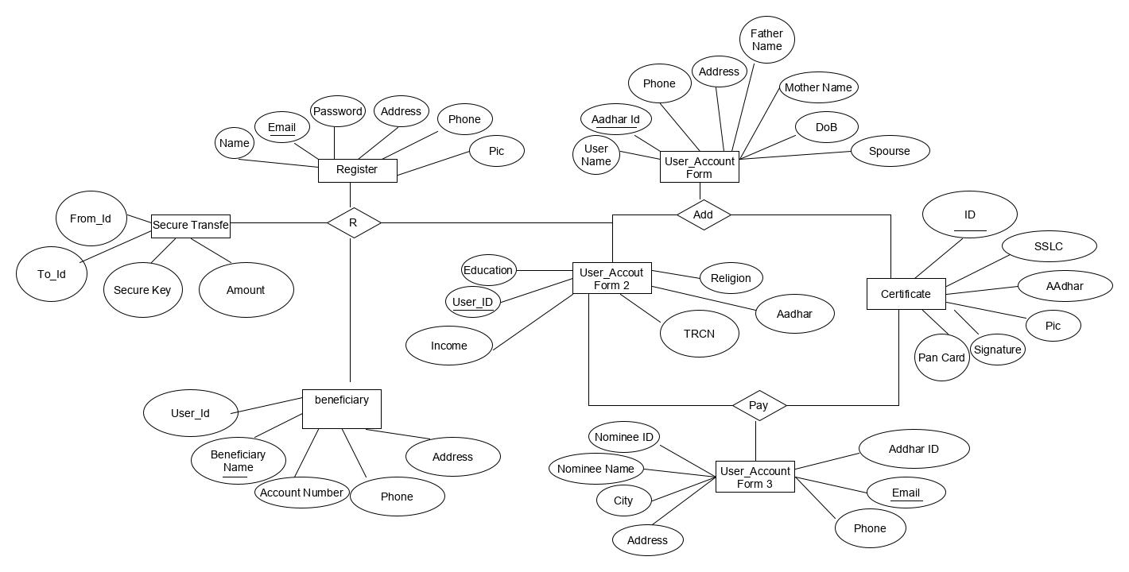
Fig: ER diagram

Activity Diagram:

Activity diagrams are a key component of the Unified Modeling Language (UML) used to illustrate workflows, processes, or activities within a system. They show the relationships between different actions and how the system transitions from one state to another. By providing a visual representation of both straightforward and intricate workflows, activity diagrams enhance understanding for developers and stakeholders regarding the interactions between various elements in a system.

An activity diagram visually presents a series of actions or flow of control in a system similar to a flowchart or a data flow diagram. Activity diagrams are often used in business process modeling. They can also describe the steps in a use case diagram. Activities modeled can be sequential and concurrent. In both cases an activity diagram will have a beginning (an initial state) and an end (a final state).
Initial State or Start Point: A small filled circle followed by an arrow represents the initial action state or the start point for any activity diagram. For activity diagram using swimlanes, make sure the start point is placed in the top left corner of the first column.
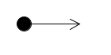
Activity or Action State: An action state represents the non-interruptible action of objects. You can draw an action state in Smart Draw using a rectangle with rounded corners.
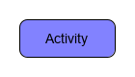
Action Flow: Action flows, also called edges and paths, illustrate the transitions from one action state to another. They are usually drawn with an arrowed line.
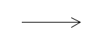

Object Flow: Object flow refers to the creation and modification of objects by activities. An object flow arrow from an action to an object means that the action creates or influences the object. An object flow arrow from an object to an action indicates that the action state uses the object.

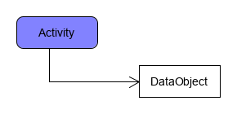

Decisions and Branching
A diamond represents a decision with alternate paths. When an activity requires a decision prior to moving on to the next activity, add a diamond between the two activities. The outgoing alternates should be labeled with a condition or guard expression. You can also label one of the paths "else."

Decision symbol - Activity diagram
Guards: In UML, guards are a statement written next to a decision diamond that must be true before moving next to the next activity. These are not essential, but are useful when a specific answer, such as "Yes, three labels are printed," is needed before moving forward.
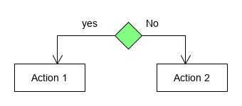

Activity diagrams are essential tools in system design and analysis, offering a visual representation of dynamic processes within organizations. They are commonly used to model business processes, depict user interactions, and assist in the design of software systems. By presenting a clear and concise overview of activities, decision points, and interactions, activity diagrams improve communication among project stakeholders and contribute to effective documentation.

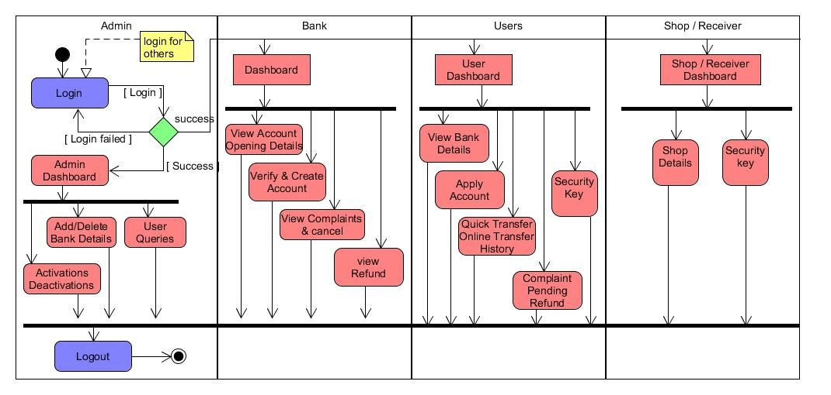

Fig: Activity Diagram
Chapter VI

SOFTWARE ENVIRONMENT

  - HTML (Hyper Text Mark-Up Language)

HTML5 is a core web technology used for structuring and presenting content on the Internet. As the fifth and most recent revision of the HTML standard from the World Wide Web Consortium (W3C), it has been in effect since October 2014. HTML5 aims to enhance the language by supporting modern multimedia while ensuring it remains easily readable by humans and consistently interpreted by computers and devices, such as web browsers and parsers. This version of HTML addresses the fact that previous HTML and XHTML versions were a mix of features from various specifications, browser implementations, and common practices. It also seeks to establish a unified markup language that can be written in either HTML or XHTML.

HTML, or HyperText Markup Language, is the fundamental markup language used for creating web pages. It blends the concepts of hypertext, which enables linking between different web pages, with markup language, which structures text documents using tags. These tags allow browsers to interpret and display content in a user-friendly way.

HTML serves as a way to annotate text so that both humans and machines can comprehend and process it effectively. Its syntax is designed to be easily readable, employing various tags to specify how the text should be formatted and displayed. This guide will walk you through the essentials of HTML, complete with examples to illustrate its functionality.

It incorporates definite handling models and expands, improves and defends the markup accessible for report and furthermore presents markup and application programming connection points (APIs) for complex web applications. For similar reasons, HTML5 is likewise a possible possibility for cross-stage portable applications. Many highlights of HTML5 have been worked with the thought of having the option to run on low-controlled gadgets like advanced mobile phones and tablets.

The HTML5 punctuation is not generally founded on SGML regardless of the likeness of its markup. It has, notwithstanding, been intended to be in reverse viable with normal parsing of more seasoned variants of HTML. It accompanies another starting line that seems to be a SGML record type statement, <! DOCTYPE HTML> , which sets off the norms consistent delivering mode

6.2 Cascading Style Sheets (CSS)
CSS (Cascading Style Sheets) is a styling language used to define the appearance and layout of a document written in a markup language. While it is most commonly employed to style web pages and user interfaces created with HTML, CSS is also utilized in conjunction with HTML and JavaScript. It is a fundamental technology for creating visually appealing web pages, user interfaces for web applications, and interfaces for many mobile applications.

CSS, or Cascading Style Sheets, is a language used to define the presentation of HTML elements on the screen. It provides a way to style and format web pages effectively. In essence, CSS simplifies the process of designing a webpage by allowing developers to separate content from design.

With CSS, you can manage various aspects of a webpage, including text color, font styles, spacing between paragraphs, and much more. While CSS is straightforward to learn, it offers powerful control over the appearance of HTML documents. It works in conjunction with HTML, enhancing the overall visual layout of web content.

CSS is designed primarily to separate content from its presentation, including aspects such as layout, colors, and fonts. This separation enhances content accessibility, provides greater flexibility and control over presentation details, and allows multiple HTML pages to share the same styling by applying a common CSS file. It also reduces complexity and redundancy in the content, such as the use of semantically irrelevant tables for layout, which was common before consistent CSS support was available in all major browsers. By separating presentation rules from HTML content, CSS enables these instructions to be maintained in a separate file or style section within the HTML document.

Another advantage of CSS is that visual updates to a document (or multiple documents) can be made quickly and efficiently by editing a few lines in a single file, rather than through a tedious (and therefore costly) process of manually updating each document line by line.

CSS3 represents an updated version of the CSS language, divided into various "modules." It
includes the previous CSS specifications while incorporating new modules. Some of the most notable CSS3 modules are:
    - Selectors
    - Box Model
    - Backgrounds and Lines
    - Image Values and Supplanted Content
    - Text Impacts
    - Multiple Segment Format
    - User Point of interaction

6.3 PHP (Hypertext Pre-Processor)

PHP is a server-side scripting language that was developed in 1995 and is primarily used for web development, though it also serves as a general-purpose programming language. Initially created by Rasmus Lerdorf in 1994, PHP's reference implementation is now maintained by The PHP Group. Originally standing for Personal Home Page, PHP now stands for PHP: Hypertext Preprocessor, a recursive acronym
.
PHP, which stands for Hypertext Preprocessor, is a powerful and popular server-side scripting language used to build dynamic and interactive web applications. This PHP tutorial aims to provide a comprehensive understanding of the PHP language. Whether you are just starting out or are an experienced PHP developer, this free tutorial will offer valuable insights and knowledge about PHP scripting.

PHP code can be seamlessly integrated with HTML, or used in conjunction with various templating engines and web frameworks. It is typically processed by a PHP interpreter, which is often implemented as a module in the web server or as a Common Gateway Interface (CGI) executable. After the PHP code is parsed and executed, the web server sends the resulting output back to the client, usually as part of the generated web page. For example, PHP can generate HTML code for a page, create images, or produce other types of data. PHP has also evolved to support command-line interface (CLI) functionality and can be used in standalone graphical applications.

The official PHP interpreter, powered by the Zend Engine, is open-source software released under the PHP License. PHP is widely supported and can be deployed on most web servers across nearly all operating systems and platforms, at no cost. Despite its widespread use, there was no formal specification or standard for the PHP language until 2014. Since then, efforts have been underway to develop a formal PHP specification.

6.4 JAVA Script

JavaScript is a dynamic programming language with unique characteristics. It is commonly used within web browsers to enable client-side scripting, allowing scripts to interact with users, manipulate the browser, communicate asynchronously, and modify the content displayed on a webpage. Often described as a foundational technology of the web, JavaScript is supported by all major browsers without requiring additional plugins. It is utilized not only for client-side web applications but also in server-side development, game creation, and both desktop and mobile applications. JavaScript is considered a model-based language with dynamic typing and first-class functions, making it a multi-paradigm language that supports object-oriented programming as well as imperative and functional programming styles.

JavaScript (often abbreviated as JS) is a lightweight, object-oriented programming language widely used for scripting on websites. It is an interpreted, comprehensive programming language that enhances web pages by enabling dynamic interactivity when integrated with HTML documents. Introduced in 1995 for use in the Netscape Navigator browser, JavaScript has since been embraced by all major graphical web browsers.

With JavaScript, developers can create modern web applications that allow users to interact with content without needing to reload the page constantly. It plays a crucial role in adding various forms of interactivity and functionality, making websites more engaging and user-friendly.

Despite some superficial similarities in naming, syntax, and standard libraries, JavaScript and Java are fundamentally different and have distinct semantics. JavaScript's syntax is derived from C, while its design and semantics are influenced by prototype-based programming languages.

JavaScript's versatility extends beyond web environments; it is also used in applications such as PDF files, site-specific browsers, and desktop widgets. The development of newer, faster JavaScript virtual machines (VMs) and platforms has increased its popularity for server-side programming. Traditionally interpreted, JavaScript is now often executed using just-in-time (JIT) compilation in modern browsers.

6.5 MYSQL

MySQL, pronounced either "My S-Q-L" or "My Sequel," is the world's second most widely used relational database management system (RDBMS) and the leading open-source RDBMS. It is named after the daughter of co-founder Michael Widenius, named My, and SQL stands for Structured Query Language.

Databases serve as crucial data repositories for software applications. Whenever a user performs a web search, logs into an account, or completes a transaction, a database system is responsible for storing that information for future access.

A relational database organizes data into separate tables, rather than storing everything in a single, large repository. This structure is optimized for efficiency and speed, utilizing physical files designed for quick access. The logical data model features components like data tables, views, rows, and columns, providing a flexible programming framework. You can establish rules that define the relationships between different data fields, such as one-to-one, one-to-many, unique, required, or optional, along with “pointers” that connect different tables. The database system enforces these rules, ensuring that your application only interacts with consistent, non-duplicated, and up-to-date data.

The "SQL" in "MySQL" stands for "Structured Query Language." SQL is the most widely used standardized language for database access. Depending on your programming context, you might write SQL directly (for tasks like report generation), embed SQL commands within other programming languages, or use a language-specific API that abstracts the SQL syntax.

MySQL is a popular choice for web applications and is a key component of the widely used XAMPP open-source web application stack. XAMPP stands for "Linux, Apache, MySQL, Perl/PHP/Python." Many well-known applications use MySQL databases, including TYPO3, MODx, Joomla, WordPress, phpBB, MyBB, and Drupal. MySQL is also employed by major websites such as Google (though not for search), Facebook, Twitter, Flickr, and YouTube.

MySQL does not include graphical user interface (GUI) tools for managing databases or the data within them. Users can utilize command-line tools provided with MySQL or opt for third-party front-end tools, desktop applications, and web applications to create and manage databases, design schemas, back up data, monitor performance, and handle data files. The official GUI tool, MySQL Workbench, is developed by Oracle and is available for free.

6.6 PhpMyAdmin

PhpMyAdmin is a free programming device written in PHP, expected to deal with the organization of MySQL over the Internet. PhpMyAdmin upholds a large number of procedure on MySQL, MariaDB and Shower. Every now and again utilized activities (overseeing data sets, tables, segments, relations, records, clients, authorizations, and so on) can be performed by means of the UI, while you actually can straightforwardly execute any SQL articulation.

phpMyAdmin is one of the most widely used applications for managing MySQL databases. With this software, users can create, update, delete, alter, import, and export MySQL database tables. It offers a variety of functions, including managing databases, relationships, tables, columns, indexes, permissions, and user accounts for both MySQL and MariaDB. Most operations can be performed through a user-friendly interface, while still allowing users to execute any SQL commands directly.

Supporting 72 languages, phpMyAdmin accommodates both right-to-left (RTL) and left-to-right (LTR) languages, making it accessible to a diverse range of users. It enables running MySQL queries, as well as repairing, optimizing, and checking tables, alongside other database management tasks. Additionally, phpMyAdmin facilitates administrative duties like database creation and query execution.

As a GUI-based application, phpMyAdmin provides a web interface for managing MySQL databases. Users can manually create databases and tables, as well as execute queries. Being web-based means it can be accessed from any computer with internet access, allowing for convenient database management from various locations.

Chapter VII

SYSTEM IMPLEMENTATION

The implementation phase of a project involves converting the theoretical design into a fully operational system. In this manner it tends to be viewed as the most basic stage in accomplishing a fruitful new framework and in giving the client, certainty that the new framework will work and be effective. The execution stage includes cautious preparation, examination of the current framework and it's requirements on execution, planning of strategies to accomplish changeover and assessment of changeover techniques.

Configurations XAMPP and Installations of Software

- Download and Install WAMPP or XAMPP
- Download Bootstrap extract to working Directory

  - Pseudo code of the project
    - Admin:
      - Login:
        - Enter admin login Id and Login password
        - Logged into AdminDashboard
        - End

Activate:
  - Select User Activations from the admin dashboard Menu
  - View the user Details and check details
  - Select Activate button to activate the user
  - Otp is sent to registered Mail Else
  - Cancel the user Request
  - End

Deactivate:
  - Select User to Deactivations from the admin dashboard Menu
  - View the user Details and check details
  - Select Deactivate button to deactivate the user
  - End

Add Bank Details:
  - Select Add Bank button from the admin dashboard Menu
  - Enter the Bank Details
  - Select Submit button provided in the form after filling the details
  - Save the data to database and Pop up message Else
  - Pop up Error Message
  - End

User Queries Details:
  - Select User Queries button from the admin dashboard Menu
  - view user queries details
  - select the user and write reply message click submit button
  - Message sent to mail provided by user Else
  - Pop up Error Message
  - End

Create Secure Number:
  - Select Secure Number Request button from the admin dashboard Menu
  - view the shop owners details
  - select the shop owners click create number button
  - Message sent to mail provided by shop owners Else
  - Error message should be popped up

Create Secure Number:

  - Select Secure Number Request button from the admin dashboard Menu
  - view the shop owners details
  - select the shop owners click create number button
  - Message sent to mail provided by shop owners Else
  - Error message should be popped up
  - End

Bank Manager

      - Create Account:

        - Select Create Account Request button from the bank manager dashboard Menu
        - View the User details
        - Select the user click to create Account
        - View and Verify Documents and certificates and select approve button
        - Message sent to mail provided by user regarding account creations Else
- Error message should be popped up
- End

Add Initial Amount :

        - . Click on Create Account Request button from the bank manager dashboard Menu
        - Enter Initial amount value and Select individual face value amount
        - Select add amount button
4. Confirmations Mail will be sent to user
Else

5.Error Message

View Complaints:
  - Click on View Complaints
  - View User Complaints Details
  - Cancel the fund transfer
  - Refund Done
  - END

    - User

      - Registrations:

- Login:
- Select register button
- Fill all the User details in register form
- select profile pic
- choose register button
- End

- Select login page and enter Use login ID and login Password
- If password and Id are correct
- Login In to dashboard Else
- Pop up Error Message
- End

Account Creations
    - Select the Bank Details file
- Fill Account Details form1, form 2 and form 3
- Select Account Creation Request Button
- Check the Status
- End

Add Beneficiary
  - Choose the Add Beneficiary
- Fill Beneficiary
- Click Save button
- Beneficiary Created
- End

Quick Transfer
    - Select Quick Transfer
- From shown beneficiary list select user to do quick transfer
- Enter the Amount to transfer
- Enter the Security Key for Secure Transfer
- Transfer successfully
- END

Online Transfer
    - Select online payment Transfer
- Enter Shop Secure Number
- Enter the Amount to transfer
- Enter the Security Key for Secure Transfer
- Transfer successfully
- END

Complaint Transfer and Refund Request
    - Select online pending Details
    - From given list of transfer select send Complaint
    - Request Sent successfully
    - END

7.2.4 Shop

Register:
    - Select online pending Details
    - From given list of transfer select send Complaint
    - Request Sent successfully
    - END

Receive Fund:
- Select login
- Enter Credential to login
- Enter Secure number to complete transaction
- If correct:
        - Success
Wrong:
        - Failed
- END

Login Page code:
<!doctype html>
<html lang="en">
<head>
<title>Secure Bank</title>
<meta charset="utf-8">
<meta name="viewport" content="width=device-width, initial-scale=1, shrink-to-fit=no">

<link href="https://fonts.googleapis.com/css?family=Open+Sans:300,400,700" rel="stylesheet">

<link rel="stylesheet" href="fonts/icomoon/style.css">
<link rel="stylesheet" href="css/bootstrap.min.css">
<link rel="stylesheet" href="css/jquery-ui.css">
<link rel="stylesheet" href="css/owl.carousel.min.css">
<link rel="stylesheet" href="css/owl.theme.default.min.css">
<link rel="stylesheet" href="css/owl.theme.default.min.css">
<link rel="stylesheet" href="css/jquery.fancybox.min.css">
<link rel="stylesheet" href="css/bootstrap-datepicker.css">
<link rel="stylesheet" href="fonts/flaticon/font/flaticon.css">
<link rel="stylesheet" href="css/aos.css">
<link rel="stylesheet" href="css/style.css">
<link rel="stylesheet" href="css/font-awesome.css">
<link rel="stylesheet" href="css/font-awesome.min.css">
</head>

<body data-spy="scroll" data-target=".site-navbar-target" data-offset="300">
<div class="site-wrap">
<div class="site-mobile-menu site-navbar-target">
<div class="site-mobile-menu-header">
<div class="site-mobile-menu-close mt-3">
<span class="icon-close2 js-menu-toggle"></span>
</div>
</div>
<div class="site-mobile-menu-body"></div>
</div>
<header class="site-navbar js-sticky-header site-navbar-target" role="banner" style="background:#333;">
<div class="container">
<div class="row align-items-center">
<div class="col-6 col-xl-2">
<h1 class="mb-0 site-logo"><a href="index.php" class="h5 mb-0"><i class="fa fa-inr" aria-hidden="true"></i> Secure Banking</a></h1>
</div>
<div class="col-12 col-md-10 d-none d-xl-block">
<nav class="site-navigation position-relative text-right" role="navigation">
<ul class="site-menu main-menu js-clone-nav mr-auto d-none d-lg-block">
<li><a href="index.php" class="nav-link">Home</a></li>
<li class="has-children">
<a href="index.php" class="nav-link">About Us</a>
<ul class="dropdown">
<li><a href="index.php" class="nav-link">Team</a></li>
<li><a href="index.php" class="nav-link">Services</a></li>
<li><a href="index.php" class="nav-link">Testimonials</a></li>
</ul>
</li>
<li><a href="login.php" class="nav-link">Login</a></li>
<li><a href="login.php" class="nav-link">Register</a></li>
<li><a href="index.php" class="nav-link">Contact</a></li>
</ul>
</nav>
</div>
<div class="col-6 d-inline-block d-xl-none ml-md-0 py-3" style="position: relative; top: 3px;"><a href="#" class="site-menu-toggle js-menu-toggle float-right"><span class="icon-menu h3"></span></a></div>
</div>
</div>
</header>
<section class="site-section bg-light" id="contact-section" data-aos="fade">
<div class="container">
<div class="row mb-5">
<div class="col-12 text-center">
<h2 class="section-title mb-3">Create your Accounts now!</h2>
</div>
</div>
<div class="row mb-5">
<div class="col-md-4 text-center">
<p class="mb-4">
<span class="icon-user d-block h2 text-primary"></span>
<span>Create Accounts</span>
</p>
</div>
<div class="col-md-4 text-center">
<p class="mb-4">
<span class="icon-sign-in d-block h2 text-primary"></span>
<span><a href="BankLogin.php">login in</a></span>
</p>
</div>
<div class="col-md-4 text-center">
<p class="mb-0">
<span class="icon-building d-block h2 text-primary"></span>
<a href="SecureTransferLogin.php">Fund Receiver Login</a>
</p>
</div>
</div>

<div class="row">
<div class="col-lg-6">
<form action="logReg.php" method="POST" class="p-4 bg-white">
<center> <h2 class="h4 text-black mb-5">Login Form</h2> </center>

<div class="form-group">
<div class="col-lg-10">
<input type="email" placeholder="Email" name="LEmail" class="form-control" required>
</div>
</div>

<div class="form-group">
<div class="col-lg-10">
<input type="password" placeholder="Password" name="LPassword" class="form-control" required>
</div>
</div>

<div class="form-group">
<div class="col-lg-10">
<input type="submit" name="Login" value="Login" class="btn btn-primary btn-md text-white">
</div>
</div>
</form>
<br>
<div class="col-lg-12">
<form action="logReg.php" method="POST" class="p-4 bg-white" enctype="multipart/form-data">
<center> <h2 class="h4 text-black mb-5">Bussiness Client</h2> </center>

<div class="form-group">
<div class="col-lg-10">
<input type="text" placeholder="Bussiness Name" name="BName" class="form-control" required>
</div>
</div>

<div class="form-group">
<div class="col-lg-10">
<input type="email" placeholder="Bussiness Email" name="BEmail" class="form-control" required>
</div>
</div>

<div class="form-group">
<div class="col-lg-10">
<input type="Password" placeholder="Create Password" name="BPassword" class="form-control" required>
</div>
</div>

<div class="form-group">
<div class="col-lg-10">
<input type="tel" placeholder="Phone Number " name="BPhone" class="form-control" required>
</div>
</div>

<div class="form-group">
<div class="col-lg-10">
<textarea type="text" placeholder="Address" cols="30" name="BAddress" rows="5" required class="form-control" ></textarea>
</div>
</div>
<div class="form-group">
<div class="col-lg-10">
<input type="file" name="ShopPic" class="form-control" required>
</div>
</div>
<div class="form-group">
<div class="col-lg-10">
<input type="submit" name="submit" value="submit" class="btn btn-primary btn-md text-white">
</div>
</div>
</form>
</div>
</div>
<div class="col-lg-6">
<form action="logReg.php" method="POST" class="p-2 bg-white" enctype="multipart/form-data">
<center><h2 class="h4 text-black mb-5">Register form</h2> </center>

<div class="form-group">
<div class="col-lg-10">
<input type="text" placeholder="Name" name="RName" class="form-control" required>
</div>
</div>
<div class="form-group">
<div class="col-lg-10">
<input type="text" placeholder="Aadhar Number" name="RAadhar" class="form-control" required>
</div>
</div>

<div class="form-group">
<div class="col-lg-10">
<input type="email" id="email" placeholder="Email" name="REmail" class="form-control" required>
</div>
</div>
<div class="form-group">
<div class="col-lg-10">
<input type="password" placeholder="Password" name="RPassword" class="form-control" required>
</div>
</div>
<div class="form-group">
<div class="col-lg-10">
<input type="password" placeholder="Confirm Password" name="RCPassword" class="form-control" required>
</div>
</div>

<div class="form-group">
<div class="col-lg-10">
<input type="tel" placeholder="phone" name="RPhone" class="form-control" required>
</div>
</div>
<div class="form-group">
<div class="col-lg-10">
<input type="date" name="RDob" class="form-control" required>
</div>
</div>

<div class="form-group">
<div class="col-lg-10">
<textarea type="text" placeholder="Address" cols="30" name="RAddress" rows="5" required class="form-control" ></textarea>
</div>
</div>

<div class="form-group">
<div class="col-lg-10">
<input type="text" name="Nationality" placeholder="Nationality" class="form-control" required>
</div>
</div>
<div class="form-group">
<div class="col-lg-10">
<input type="file" name="RProfile_Pic" class="form-control" required>
</div>
</div>
<div class="form-group">
<div class="col-lg-10">
<select name="RSecurity_Question" class="form-control" required>
<option value="What is your Best Friend Name">What is your Best Friend Name</option>
<option value="What is your First Mobile Number">What is your First Mobile Number</option>
<option value="What is your vehicle number">What is your vehicle number</option>
</select>
</div>
</div>
<div class="form-group">
<div class="col-lg-10">
<input type="text" name="RSecurity_Answer" placeholder="Answer" class="form-control" required>
</div>
</div>
<div class="form-group">
<div class="col-lg-8">
<input type="submit" name="Register" value="Register" class="btn btn-primary btn-md text-white">
</div>
</div>
</form>
</div>
</div>
</div>
</section>

<footer class="site-footer">
<div class="container">
<div class="row">
<div class="col-lg-12">
<div class="row">
<div class="col-lg-6">
<h2 class="footer-heading mb-4">About Us</h2>
<p>Secure Electronic Money Transfer .</p>
</div>
<div class="col-lg-6 footer-social">
<h2 class="footer-heading mb-4">Follow Us</h2>
<a href="#" class="pl-0 pr-3"><span class="icon-facebook"></span></a>
<a href="#" class="pl-3 pr-3"><span class="icon-twitter"></span></a>
<a href="#" class="pl-3 pr-3"><span class="icon-instagram"></span></a>
<a href="#" class="pl-3 pr-3"><span class="icon-linkedin"></span></a>
</div>
</div>
</div>
</div>
<div class="row pt-5 mt-5 text-center">
<div class="col-md-12">
<div class="border-top pt-5">
<!-- Link back to Colorlib can't be removed. Template is licensed under CC BY 3.0. -->
<p>Copyright &copy;
<script>document.write(new Date().getFullYear());</script> All rights reserved | made
with <i class="icon-heart-o" aria-hidden="true"></i> by <a href="" target="">us</a>
</p>
<!-- Link back to Colorlib can't be removed. Template is licensed under CC BY 3.0. -->
</div>
</div>
</div>
</div>
</footer>
</div> <!-- .site-wrap -->
<script src="js/jquery-3.3.1.min.js"></script>
<script src="js/jquery-ui.js"></script>
<script src="js/popper.min.js"></script>
<script src="js/bootstrap.min.js"></script>
<script src="js/owl.carousel.min.js"></script>
<script src="js/jquery.countdown.min.js"></script>
<script src="js/jquery.easing.1.3.js"></script>
<script src="js/aos.js"></script>
<script src="js/jquery.fancybox.min.js"></script>
<script src="js/jquery.sticky.js"></script>
<script src="js/isotope.pkgd.min.js"></script>
<script src="js/main.js"></script>
</body>
</html>

Server-side code for login Page:
<?php
session_start();
include('database.php');
if(isset($_POST['Login']))
{
$LEmail = $_POST['LEmail'];
$LPassword = $_POST['LPassword'];

if($LEmail== 'admin@gmail.com' && $LPassword='admin')
{
$_SESSION['admin']='admin@gmail.com';
$_SESSION['Image']='images/admin.png';
header("Location:admindashboard.php");
}
else
{

$sqlc = "SELECT Email,Password,OTP,Profile_Pic,Type FROM registration WHERE Email = '$LEmail' AND Password = '$LPassword'";
$result = $conn->query($sqlc);
if ($result->num_rows > 0)
{
while($row=$result->fetch_assoc())
{
$_SESSION['Image']=$row['Profile_Pic'];
$_SESSION['UEmail']=$row['Email'];
$OTP=$row['OTP'];
$Type=$row['Type'];
}
if($Type == 'User' && $OTP =='Verified')
{
header("Location:userDashboard.php");
}
else if($OTP!= '00000' && $OTP!= 'Verified' || $Type== 'User')
{
header("Location:OTP.php");
}
if($Type == 'Shops' && $OTP =='Verified')
{ $_SESSION['ShopEmail']=$_SESSION['UEmail'];
header("Location:ShopDashboard.php");
}
else if($OTP!= '0' && $OTP!= 'Verified' || $Type== 'Shops')
{
header("Location:OTP.php");
}
}
else
{
echo'<script lang="javascript">;
alert("Login Failed, check your Email id and Password");
window.location.href="login.php";
</script>';
}
}
}
if(isset($_POST['Register']))
{
$RName = $_POST['RName'];
$RAadhar_Number = $_POST['RAadhar'];
$REmail = $_POST['REmail'];
$RPassword = $_POST['RPassword'];
$RCPassword = $_POST['RCPassword'];
if(strlen($RPassword < 8) && strlen($RCPassword)< 8)
{
echo"<script> alert('Password length is too short. try again')</script>;";
}
$RPhone = $_POST['RPhone'];
$RDob = $_POST['RDob'];
$RAddress = $_POST['RAddress'];
$Nationality=$_POST['Nationality'];
$target_file = basename($_FILES['RProfile_Pic']['name']);
$RSecurity_Question=$_POST['RSecurity_Question'];
$RSecurity_Answer =$_POST['RSecurity_Answer'];
$sqlc = "SELECT Email,Password FROM registration WHERE Email = '$REmail' AND Password = '$RPassword'";
$result = $conn->query($sqlc);
if ($result->num_rows > 0)
{
while($row = $result->fetch_assoc())
{
if($row["Email"]==$REmail && $row["Password"]==$RPassword)
{
echo '<script>alert("Registeration Failed User Email Already Exits!!");window.location.href="login.php";</script>';
}
}
}
else
{
if($RPassword == $RCPassword)
{ $dirname="uploads/Registration/$REmail";
if(is_dir($dirname))
{ mkdir("uploads/Registration/$REmail");
$target_dir = "uploads/Registration/$REmail";
$target_file = $target_dir."/".$target_file; move_uploaded_file($_FILES['RProfile_Pic']['tmp_name'],$target_file);
}
else
{
$target_file = basename($_FILES["RProfile_Pic"]["name"]); mkdir("uploads/Registration/$REmail");
$target_dir = "uploads/Registration/$REmail";
$target_file = $target_dir."/".$target_file; move_uploaded_file($_FILES['RProfile_Pic']['tmp_name'],$target_file);
$qry="INSERT INTO registration(Name,Aadhar_Number,Email,Password,Phone,Dob,Address,Nationality,Profile_Pic,Security_Question,Security_Answer,Status,OTP,Type)VALUES ('$RName','$RAadhar_Number','$REmail','$RPassword','$RPhone','$RDob','$RAddress','$Nationality','$target_file','$RSecurity_Question','$RSecurity_Answer','Not Set','0','User')";
$res=$conn->query($qry);
if($res == true)
{
echo”'<script>alert("Successfully Registered");window.location.href="login.php";</script>';
}
else
{
echo 'error'.$conn->error;
}
}
}
else
{
echo '<script>alert("Password and Repeat_Password mis matched..");window.location.href="login.php";</script>';
}
}
}
if(isset($_POST['submit']))
{
$BName = $_POST['BName'];
$BEmail = $_POST['BEmail'];
$BPassword = $_POST['BPassword'];
$BPhone = $_POST['BPhone'];
$BAddress = $_POST['BAddress'];
$target_file = basename($_FILES['ShopPic']['name']);
$sqlc = "SELECT Email,Password FROM registration WHERE Email = '$BEmail' AND Password = '$BPassword'";
$result = $conn->query($sqlc);
if ($result->num_rows > 0)
{
while($row = $result->fetch_assoc())
{
if($row["Email"]==$BEmail && $row["Password"]==$BPassword)
{
echo '<script>alert("Registeration Failed User Shops Email Already Exits!!");window.location.href="login.php";</script>';
}
}
}
else
{
$dirname="uploads/shops/$BEmail";
if(is_dir($dirname))
{
mkdir("uploads/shops/$BEmail");
$target_dir = "uploads/shops/$BEmail";
$target_file = $target_dir."/".$target_file;
move_uploaded_file($_FILES['ShopPic']['tmp_name'],$target_file);
}
else
{
$target_file = basename($_FILES["ShopPic"]["name"]);
mkdir("uploads/shops/$BEmail");
$target_dir = "uploads/shops/$BEmail";
$target_file = $target_dir."/".$target_file;
move_uploaded_file($_FILES['ShopPic']['tmp_name'],$target_file);
$Random=rand(1000,9999);
$qry="INSERT INTO registration(Name,Aadhar_Number,Email,Password,Phone,Dob,Address,Nationality,Profile_Pic,Security_Question,Security_Answer,Status,OTP,Type)VALUES('$BName','$Random','$BEmail','$BPassword','$BPhone','','$BAddress','','$target_file','','','Not Set','0','Shops')";
$res=$conn->query($qry);
if($res == true)
{
echo '<script>alert("Successfully Registered");window.location.href="login.php";</script>';
}
else
{
echo 'error'.$conn->error;
}
}
}
}
?>

Secure Transfer Code:
<!doctype html>
<?php
session_start();
include("database.php");
if(!isset($_SESSION['UEmail']))
{
header('location:index.php');
}
else
{
$now = time(); // Checking the time now when home page starts.
if ($now > $_SESSION['expire'])
{
unset($_SESSION['start']);
unset($_SESSION['expire']);
echo "<script>alert('Your Session expired!!! try Again');</script>";
header('location:PendingDetails.php');
}
else
{
$UEmail=$_SESSION['UEmail'];
$Q="SELECT Account_No FROM account WHERE Customer_Email_ID='$UEmail'";
$R=$conn->query($Q);
if($R->num_rows > 0)
{
while($Row=$R->fetch_assoc())
{
$Account_No=$Row['Account_No'];
}
}
$_SESSION['SenderAccount_No']=$Account_No;

?>
<html lang="en">
<head>
<title>Secure Transfer</title>
<meta charset="utf-8">
<meta http-equiv="refresh" content="305">
<meta name="viewport" content="width=device-width, initial-scale=1, shrink-to-fit=no">

<link href="https://fonts.googleapis.com/css?family=Open+Sans:300,400,700" rel="stylesheet">
<link rel="stylesheet" href="fonts/icomoon/style.css">

<link rel="stylesheet" href="css/bootstrap.min.css">
<link rel="stylesheet" href="css/jquery-ui.css">
<link rel="stylesheet" href="css/owl.carousel.min.css">
<link rel="stylesheet" href="css/owl.theme.default.min.css">
<link rel="stylesheet" href="css/owl.theme.default.min.css">
<link rel="stylesheet" href="css/jquery.fancybox.min.css">
<link rel="stylesheet" href="css/bootstrap-datepicker.css">
<link rel="stylesheet" href="fonts/flaticon/font/flaticon.css">
<link rel="stylesheet" href="css/aos.css">
<link rel="stylesheet" href="css/style.css">
<link rel="stylesheet" href="css/font-awesome.css">
<link rel="stylesheet" href="css/font-awesome.min.css">
</head>
<body data-spy="scroll" data-target=".site-navbar-target" data-offset="300">
<div class="site-wrap">
<div class="site-mobile-menu site-navbar-target">
<div class="site-mobile-menu-header">
<div class="site-mobile-menu-close mt-3">
<span class="icon-close2 js-menu-toggle"></span>
</div>
</div>
<div class="site-mobile-menu-body"></div>
</div>
<header class="site-navbar js-sticky-header site-navbar-target" role="banner" style="background:#333;">
<div class="container">
<div class="row align-items-center">
<div class="col-6 col-xl-2">
<h1 class="mb-0 site-logo"><a href="index.php" class="h5 mb-0"><i class="fa fa-inr" aria-hidden="true"></i> Secure Banking</a></h1>
</div>
<div class="col-12 col-md-10 d-none d-xl-block">
<nav class="site-navigation position-relative text-right" role="navigation">

<ul class="site-menu main-menu js-clone-nav mr-auto d-none d-lg-block">
<li><a href="Userdashboard.php" class="nav-link">Dashboard</a></li>
<li><a href="Bankdetails.php" class="nav-link">Bank Details</a></li>
<li><a href="Account.php" class="nav-link">Account Details</a></li>
<li class="has-children">
<a href="#.php" class="nav-link">Transfer</a>
<ul class="dropdown">
<li><a href="AddBeneficiary.php" class="nav-link">Add Beneficiary</a></li>
<li><ahref="DeleteBeneficiary.php"class="nav-link">Delete Beneficiary</a></li>
<li><a href="QuickTransfer.php" class="nav-link">QuickTransfer</a></li>
<li><a href="OnlinePyament.php" class="nav-link">Online Payment</a></li>
<li><a href="TransferHistory.php" class="nav-link">Transfer History</a></li>
</ul>
</li>
<li class="has-children">
<a href="#" class="nav-link">Complaints</a>
<ul class="dropdown">
<li><a href="PendingDetails.php" class="nav-link">Pending Transfer</a></li>
<li><a href="RaisedComplaints.php" class="nav-link">Raised Complaints</a></li>
<li><a href="ViewComplaints.php" class="nav-link">View Complaints</a></li>
</ul>
</li>
</li>
<li class="has-children">
<a href="#" class="nav-link"><img src="<?php echo $_SESSION['Image'];?>" style="border-radius:40px;" height="50" width="60"></a>
<ul class="dropdown">
<li><a href="ApplicationDetails.php" class="nav-link">Application Details</a></li>
<li><a href="logout.php" class="nav-link">Logout</a></li>
</ul>
</li>
</ul>
</nav>
</div>
<div class="col-6 d-inline-block d-xl-none ml-md-0 py-3" style="position: relative; top: 3px;"><a href="#" class="site-menu-toggle js-menu-toggle float-right"><span class="icon-menu h3"></span></a></div>
</div>
</div>
</header>
<section class="site-section bg-light" id="contact-section" data-aos="fade">
<div class="container">
<div class="row mb-5">
<div class="col-12 text-center">
<h2 class="section-title mb-3">Secure Fund Transfer</h2>
<div class="panel panel-default">
<div class="panel-body">
<table class="table table-bordered"> <div class="panel panel-default">
<table class="table table-bordered" style="background-color:#edf1f2">
<tbody>
<td colspan='2'> <form action="Transfer2.php" method="POST" class="p-4 bg-white">
<div class="form-group">
<div class="col-lg-12">
<input type="text" placeholder="Security Key" name="SenderSecurityKey" class="form-control" required>
</div>
</div>
</td>
</tr>
<tr>
<td colspan='2'>
<div class="form-group">
<div class="col-lg-12">
<input type="submit" name="TransferSubmit" class="btn btn-lg btn-danger" value="Submit" required> </div>
</div> </td></tr>
</form>
</tbody>
</table>
</div>
</div>
</div>
</div>
</div>
</section>
<footer class="site-footer">
<div class="container">
<div class="row">
<div class="col-lg-12">
<div class="row">
<div class="col-lg-6">
<h2 class="footer-heading mb-4">About Us</h2>
<p>Secure Electronic Money Transfer .</p>
</div>
<div class="col-lg-6 footer-social">
<h2 class="footer-heading mb-4">Follow Us</h2>
<a href="#" class="pl-0 pr-3"><span class="icon-facebook"></span></a>
<a href="#" class="pl-3 pr-3"><span class="icon-twitter"></span></a>
<a href="#" class="pl-3 pr-3"><span class="icon-instagram"></span></a>
<a href="#" class="pl-3 pr-3"><span class="icon-linkedin"></span></a>
</div>
</div>
</div>
</div>
<div class="row pt-5 mt-5 text-center">
<div class="col-md-12">
<div class="border-top pt-5">
<!-- Link back to Colorlib can't be removed. Template is licensed under CC BY 3.0. -->
<p>Copyright &copy;
<script>document.write(new Date().getFullYear());</script> All rights reserved | made
with <i class="icon-heart-o" aria-hidden="true"></i> by <a href="" target="">us</a>
</p>
<!-- Link back to Colorlib can't be removed. Template is licensed under CC BY 3.0. -->
</div>
</div>
</div>
</div>
</footer>
</div> <!-- .site-wrap -->
<script src="js/jquery-3.3.1.min.js"></script>
<script src="js/jquery-ui.js"></script>
<script src="js/popper.min.js"></script>
<script src="js/bootstrap.min.js"></script>
<script src="js/owl.carousel.min.js"></script>
<script src="js/jquery.countdown.min.js"></script>
<script src="js/jquery.easing.1.3.js"></script>
<script src="js/aos.js"></script>
<script src="js/jquery.fancybox.min.js"></script>
<script src="js/jquery.sticky.js"></script>
<script src="js/isotope.pkgd.min.js"></script>
<script src="js/main.js"></script>
</body>
</html>
<?php
}
}
?>

Transfer summary coding
<!doctype html>
<?php
session_start();
include("database.php");
if(!isset($_SESSION['UEmail']))
{
header('location:index.php');
}
$UEmail=$_SESSION['UEmail'];
$q1="SELECT * FROM account WHERE Customer_Email_ID='$UEmail'";
$res1=$conn->query($q1);
{
while($rw1=$res1->fetch_assoc())
{
$Account_No=$rw1['Account_No'];
}
}
?>
<html lang="en">
<head>
<title>Transfer Histroy</title>
<meta charset="utf-8">
<meta name="viewport" content="width=device-width, initial-scale=1, shrink-to-fit=no">
<link href="https://fonts.googleapis.com/css?family=Open+Sans:300,400,700" rel="stylesheet">
<link rel="stylesheet" href="fonts/icomoon/style.css">
<link rel="stylesheet" href="css/bootstrap.min.css">
<link rel="stylesheet" href="css/jquery-ui.css">
<link rel="stylesheet" href="css/owl.carousel.min.css">
<link rel="stylesheet" href="css/owl.theme.default.min.css">
<link rel="stylesheet" href="css/owl.theme.default.min.css">
<link rel="stylesheet" href="css/jquery.fancybox.min.css">
<link rel="stylesheet" href="css/bootstrap-datepicker.css">
<link rel="stylesheet" href="fonts/flaticon/font/flaticon.css">
<link rel="stylesheet" href="css/aos.css">
<link rel="stylesheet" href="css/style.css">
<link rel="stylesheet" href="css/font-awesome.css">
<link rel="stylesheet" href="css/font-awesome.min.css">
</head>
<body data-spy="scroll" data-target=".site-navbar-target" data-offset="300">
<div class="site-wrap">
<div class="site-mobile-menu site-navbar-target">
<div class="site-mobile-menu-header">
<div class="site-mobile-menu-close mt-3">
<span class="icon-close2 js-menu-toggle"></span>
</div>
</div>
<div class="site-mobile-menu-body"></div>
</div>
<header class="site-navbar js-sticky-header site-navbar-target" role="banner" style="background:#333;">
<div class="container">
<div class="row align-items-center">
<div class="col-6 col-xl-2">
<h1 class="mb-0 site-logo"><a href="index.php" class="h5 mb-0"><i class="fa fa-inr" aria-hidden="true"></i> Secure Banking</a></h1>
</div>
<div class="col-12 col-md-10 d-none d-xl-block">
<nav class="site-navigation position-relative text-right" role="navigation">
<ul class="site-menu main-menu js-clone-nav mr-auto d-none d-lg-block">
<li><a href="Userdashboard.php" class="nav-link">Dashboard</a></li>
<li><a href="Bankdetails.php" class="nav-link">Bank Details</a></li>
<li><a href="Account.php" class="nav-link">Account Details</a></li>
<li class="has-children">
<a href="#.php" class="nav-link">Transfer</a>
<ul class="dropdown">
<li><a href="AddBeneficiary.php" class="nav-link">Add Beneficiary</a></li>
<li><a href="DeleteBeneficiary.php" class="nav-link">Delete Beneficiary</a></li>
<li><a href="QuickTransfer.php" class="nav-link">QuickTransfer</a></li>
<li><a href="OnlinePyament.php" class="nav-link">Online Payment</a></li>
<li><a href="TransferHistory.php" class="nav-link">Transfer History</a></li>
</ul>
</li>
<li class="has-children">
<a href="#" class="nav-link">Complaints</a>
<ul class="dropdown">
<li><a href="PendingDetails.php" class="nav-link">Pending Transfer</a></li>
<li><a href="RaisedComplaints.php" class="nav-link">Raised Complaints</a></li>
<li><a href="ViewComplaints.php" class="nav-link">View Complaints</a></li>
</ul>
</li>
<li class="has-children">
<a href="#" class="nav-link"><img src="<?php echo $_SESSION['Image'];?>" style="border-radius:40px;" height="50" width="60"></a>
<ul class="dropdown">
<li><a href="ApplicationDetails.php" class="nav-link">Application Details</a></li> <li><a href="logout.php" class="nav-link">Logout</a></li>
</ul>
</li>
</ul>
</nav>
</div>
<div class="col-6 d-inline-block d-xl-none ml-md-0 py-3" style="position: relative; top: 3px;"><a href="#" class="site-menu-toggle js-menu-toggle float-right"><span class="icon-menu h3"></span></a></div>
</div>
</div>
</header>
<section class="site-section bg-light" id="contact-section" data-aos="fade">
<div class="container">
<div class="row mb-5">
<div class="col-12 text-center">
<div class="panel panel-default">
<table class="table table-bordered" style="background-color:#edf1f2">
<thead>
<th>Transfer ID</th>
<th>Remarks</th>
<th>Date</th>
<th>Amount</th>
<th>Account Number</th>
<th>Total</th>
</thead>
<tbody>
<?php
$Debit_Amount=0;
$Total=0;
$q="SELECT * FROM transaction WHERE Account_Number='$Account_No'";
$res=$conn->query($q);
if($res->num_rows > 0)
{
while($rw=$res->fetch_assoc())
{
echo"<tr>";
echo"<td>".$rw['Transfer_ID']."</td>";
echo"<td>".$rw['Status']."</td>";
echo"<td>".$rw['Credit_Date']."</td>"; $Credit_Amount=$rw['Credit_Amount']; echo"<td style='color:green'>Rs ".$rw['Credit_Amount']." /- (Cr)</td>"; echo"<td>To Your Account</td>";
$Total=$Total+($Credit_Amount-$Debit_Amount);
echo"<td><strong>Rs ".$Total." /-</strong></td>";
echo"</tr>";
}
}
$q="SELECT * FROM securetransfer WHERE FromAccountNumber='$Account_No' AND TransferStatus='Transfered'";
$res=$conn->query($q);
if($res->num_rows > 0)
{
while($rw=$res->fetch_assoc())
{
$Total=0;
echo"<tr>";
echo"<td>".$rw['Transfer_ID']."</td>";
echo"<td>Transfered By you</td>";
echo"<td>".$rw['DateTime']."</td>"; $Debit_Amount=$Debit_Amount+$rw['Amount']; echo"<td style='color:red'>Rs ".$rw['Amount']." /- (Cr)</td>";
echo"<td>".$rw['ToAccountNumber']."</td>"; $Total=$Total+($Credit_Amount-$Debit_Amount);
echo"<td><strong>Rs ".$Total." /-</strong></td>";
echo"</tr>";
echo"</tr>";
}
}
?>
<tbody>
</table>
</div>
</div>
</div>
</section>
<footer class="site-footer">
<div class="container">
<div class="row">
<div class="col-lg-12">
<div class="row">
<div class="col-lg-6">
<h2 class="footer-heading mb-4">About Us</h2>
<p>Secure Electronic Money Transfer .</p>
</div>
<div class="col-lg-6 footer-social">
<h2 class="footer-heading mb-4">Follow Us</h2>
<a href="#" class="pl-0 pr-3"><span class="icon-facebook"></span></a>
<a href="#" class="pl-3 pr-3"><span class="icon-twitter"></span></a>
<a href="#" class="pl-3 pr-3"><span class="icon-instagram"></span></a>
<a href="#" class="pl-3 pr-3"><span class="icon-linkedin"></span></a>
</div>
</div>
</div>
</div>
<div class="row pt-5 mt-5 text-center">
<div class="col-md-12">
<div class="border-top pt-5">
<!-- Link back to Colorlib can't be removed. Template is licensed under CC BY 3.0. -->
<p>Copyright &copy;
<script>document.write(new Date().getFullYear());</script> All rights reserved | made
with <i class="icon-heart-o" aria-hidden="true"></i> by <a href="" target="">us</a>
</p>
<!-- Link back to Colorlib can't be removed. Template is licensed under CC BY 3.0. -->
</div>
</div>
</div>
</div>
</footer>
</div> <!-- .site-wrap -->
<script src="js/jquery-3.3.1.min.js"></script>
<script src="js/jquery-ui.js"></script>
<script src="js/popper.min.js"></script>
<script src="js/bootstrap.min.js"></script>
<script src="js/owl.carousel.min.js"></script>
<script src="js/jquery.countdown.min.js"></script>
<script src="js/jquery.easing.1.3.js"></script>
<script src="js/aos.js"></script>
<script src="js/jquery.fancybox.min.js"></script>
<script src="js/jquery.sticky.js"></script>
<script src="js/isotope.pkgd.min.js"></script>
<script src="js/main.js"></script>
</body>
</html>

Quick Transfer code:

<!doctype html>
<?php
session_start();
include("database.php");
if(!isset($_SESSION['UEmail']))
{
header('location:index.php');
}
$UEmail=$_SESSION['UEmail'];
?>
<html lang="en">
<head>
<title>Admin Activate</title>
<meta charset="utf-8">
<meta name="viewport" content="width=device-width, initial-scale=1, shrink-to-fit=no">

<link href="https://fonts.googleapis.com/css?family=Open+Sans:300,400,700" rel="stylesheet">
<link rel="stylesheet" href="fonts/icomoon/style.css">

<link rel="stylesheet" href="css/bootstrap.min.css">
<link rel="stylesheet" href="css/jquery-ui.css">
<link rel="stylesheet" href="css/owl.carousel.min.css">
<link rel="stylesheet" href="css/owl.theme.default.min.css">
<link rel="stylesheet" href="css/owl.theme.default.min.css">
<link rel="stylesheet" href="css/jquery.fancybox.min.css">
<link rel="stylesheet" href="css/bootstrap-datepicker.css">
<link rel="stylesheet" href="fonts/flaticon/font/flaticon.css">
<link rel="stylesheet" href="css/aos.css">
<link rel="stylesheet" href="css/style.css">
<link rel="stylesheet" href="css/font-awesome.css">
<link rel="stylesheet" href="css/font-awesome.min.css">
</head>
<body data-spy="scroll" data-target=".site-navbar-target" data-offset="300">
<div class="site-wrap">
<div class="site-mobile-menu site-navbar-target">
<div class="site-mobile-menu-header">
<div class="site-mobile-menu-close mt-3">
<span class="icon-close2 js-menu-toggle"></span>
</div>
</div>
<div class="site-mobile-menu-body"></div>
</div>
<header class="site-navbar js-sticky-header site-navbar-target" role="banner" style="background:#333;">
<div class="container">
<div class="row align-items-center">
<div class="col-6 col-xl-2">
<h1 class="mb-0 site-logo"><a href="index.php" class="h5 mb-0"><i class="fa fa-inr" aria-hidden="true"></i> Secure Banking</a></h1>
</div>
<div class="col-12 col-md-10 d-none d-xl-block">
<nav class="site-navigation position-relative text-right" role="navigation">
<ul class="site-menu main-menu js-clone-nav mr-auto d-none d-lg-block">
<li><a href="Userdashboard.php" class="nav-link">Dashboard</a></li>
<li><a href="Bankdetails.php" class="nav-link">Bank Details</a></li>
<li><a href="Account.php" class="nav-link">Account Details</a></li>
<li class="has-children">
<a href="#.php" class="nav-link">Transfer</a>
<ul class="dropdown">
<li><a href="AddBeneficiary.php" class="nav-link">Add Beneficiary</a></li>
<li><a href="DeleteBeneficiary.php" class="nav-link">Delete Beneficiary</a></li>
<li><a href="QuickTransfer.php" class="nav-link">QuickTransfer</a></li>
<li><a href="OnlinePyament.php" class="nav-link">Online Payment</a></li>
<li><a href="TransferHistory.php" class="nav-link">Transfer History</a></li>
</ul>
</li>
<li class="has-children">
<a href="#" class="nav-link">Complaints</a>
<ul class="dropdown">
<li><a href="PendingDetails.php" class="nav-link">Pending Transfer</a></li>
<li><a href="RaisedComplaints.php" class="nav-link">Raised Complaints</a></li>
<li><a href="ViewComplaints.php" class="nav-link">View Complaints</a></li>
</ul>
</li>
<li class="has-children">
<a href="#" class="nav-link"><img src="<?php echo $_SESSION['Image'];?>" style="border-radius:40px;" height="50" width="60"></a>
<ul class="dropdown">
<li><a href="ApplicationDetails.php" class="nav-link">Application Details</a></li>
<li><a href="logout.php" class="nav-link">Logout</a></li>
</ul>
</li>
</ul>
</nav>
</div>
<div class="col-6 d-inline-block d-xl-none ml-md-0 py-3" style="position: relative; top: 3px;"><a href="#" class="site-menu-toggle js-menu-toggle float-right"><span class="icon-menu h3"></span></a></div>
</div>
</div>
</header>
<section class="site-section bg-light" id="contact-section" data-aos="fade">
<div class="container">
<div class="row mb-5">
<div class="col-12 text-center">
<h2 class="section-title mb-3">Beneficiary Account Details</h2>
<div class="panel panel-default">
<div class="panel-body">
<table class="table table-bordered">
<div class="panel panel-default">
<table class="table table-bordered" style="background-color:#edf1f2">
<thead>
<tr><th>Beneficiary Bank</th>
<th>Beneficiary Name</th>
<th>Account Number </th>
<th>Beneficiary Email </th>
<th>Beneficiary Phone</th>
<th>Beneficiary IFSC</th>
</tr>
</thead>
<tbody>
<?php
$sql ="SELECT * FROM beneficiary WHERE UserEmail='$UEmail'";
$res = $conn->query($sql);
if ($res->num_rows > 0)
{
while($row = $res->fetch_assoc())
{
echo'<tr class="success">'; echo'<td>'.$row['BeneficiaryHostBank'].'</td>';
echo'<td>'.$row['BeneficiaryName'].'</td>'; $Beneficiary_Account_Number =$row['Beneficiary_Account_Number']; echo'<td> '.$row['Beneficiary_Account_Number'].'</td>'; echo'<td> '.$row['BeneficiaryEmail'].'</td>'; echo'<td> '.$row['BeneficiaryPhone'].'</td>';
echo'<td> '.$row['BeneficiaryIFSC'].'</td>'; echo'<td><a class="btn btn-sm btn-success" href="Transfer.php?q='.$Beneficiary_Account_Number.'">Transfer Money</a></td>';
echo'</tr>';
}
} else
{
echo "<tr><td colspan='5'>Beneficiary Details are Yet to Add</td></tr>";
}
?>
</tbody>
</table>
</div>
<?php
?>
</table>
</div>
</div>
</div>
</div>
</section>
<footer class="site-footer">
<div class="container">
<div class="row">
<div class="col-lg-12">
<div class="row">
<div class="col-lg-6">
<h2 class="footer-heading mb-4">About Us</h2>
<p>Secure Electronic Money Transfer .</p>
</div>
<div class="col-lg-6 footer-social">
<h2 class="footer-heading mb-4">Follow Us</h2>
<a href="#" class="pl-0 pr-3"><span class="icon-facebook"></span></a>
<a href="#" class="pl-3 pr-3"><span class="icon-twitter"></span></a>
<a href="#" class="pl-3 pr-3"><span class="icon-instagram"></span></a>
<a href="#" class="pl-3 pr-3"><span class="icon-linkedin"></span></a>
</div>
</div>
</div>
</div>
<div class="row pt-5 mt-5 text-center">
<div class="col-md-12">
<div class="border-top pt-5">
<!-- Link back to Colorlib can't be removed. Template is licensed under CC BY 3.0. -->
<p>Copyright &copy;
<script>document.write(new Date().getFullYear());</script> All rights reserved | made
with <i class="icon-heart-o" aria-hidden="true"></i> by <a href="" target="">us</a>
</p>
<!-- Link back to Colorlib can't be removed. Template is licensed under CC BY 3.0. --> <div>
</div>
</div>
</div>
</footer>
</div> <!-- .site-wrap -->
<script src="js/jquery-3.3.1.min.js"></script>
<script src="js/jquery-ui.js"></script>
<script src="js/popper.min.js"></script>
<script src="js/bootstrap.min.js"></script>
<script src="js/owl.carousel.min.js"></script>
<script src="js/jquery.countdown.min.js"></script>
<script src="js/jquery.easing.1.3.js"></script>
<script src="js/aos.js"></script>
<script src="js/jquery.fancybox.min.js"></script>
<script src="js/jquery.sticky.js"></script>
<script src="js/isotope.pkgd.min.js"></script>
<script src="js/main.js"></script>

</body>
</html>

CHAPTER VIII
SOFTWARE TESTING

Testing involves evaluating the functionality of an application to identify its strengths and weaknesses. This process assesses various aspects such as response times, data integrity, usability, and overall reliability. The goal is to execute the program with the specific aim of uncovering errors and validating that all requirements are met.

Testing Objectives
- Error Detection: Testing aims to run a program to identify errors.
- Effective Testing: A good test should have a high chance of discovering hidden issues.
- Successful Testing: A successful test reveals previously unnoticed mistakes.

Testing is crucial for ensuring system success. It operates under the assumption that all system components are functioning correctly. Software testing is an evaluative process conducted to provide stakeholders with insights into the quality of the product or service being tested, relative to its intended environment. It also offers an objective, independent view of the software, allowing the business to understand and assess risks associated with its deployment. Testing methods include running a program or application with the goal of finding software defects. It can also be described as the process of verifying that a software program or product meets business and technical requirements, ensuring it performs as expected and can be implemented with the desired characteristics.
Software Testing, contingent upon the testing strategy utilized, can be executed whenever in the improvement cycle, but the most test exertion is utilized after the prerequisites have been characterized and coding of project has been finished.
Testing includes following types:

1. Unit Test
2. Integration Test
3. System Test
4. Black Box Test
5. White Box Test

8.1.1 Unit Test
In unit testing, the application developer tests individual components of the system. Since the application is divided into various modules, unit testing focuses on each submodule independently to detect errors. This approach allows developers to identify and address issues in each module. During testing, techniques such as tracing and breakpoints are utilized at different stages. For this project, unit testing was conducted on each module using specific test data to ensure accurate functionality. The unit testing process was completed successfully.
8.1.2 Integrations Test
Integration testing involves evaluating the entire system once all modules and submodules have been combined. This type of testing ensures that individual modules, which function correctly on their own, work seamlessly together without errors when integrated. The goal is to confirm that the interconnected modules cooperate effectively to achieve the application’s overall objectives.
In this project, integration testing was performed with all modules combined, and no errors were found. Various data tests were conducted, and the application demonstrated flawless performance, meeting the user's expectations.

8.1.3 System Test
System testing is defined as the process of validating that the system performs as expected from the user's perspective. It provides final confirmation that the system meets all functional, behavioral, and performance requirements.
For this project, system testing was conducted with all modules combined, and no errors were found. The system was observed to function flawlessly, fulfilling all user requirements and meeting the overall expectations.

8.1.4 Black Box Test
Black box testing is a testing approach where test cases are derived from the program's specifications rather than its internal workings. The system is treated as a "black box," with its behavior assessed by examining its inputs and outputs. This method focuses solely on evaluating the functionality of the software, without considering its internal implementation or performance.

8.1.5 White Box Test

White box testing, also known as clear box testing, glass box testing, or structural testing, involves designing tests based on the internal structure of the system. This approach requires a detailed understanding of the software's code and architecture. Test cases are created to cover all possible paths through the code, allowing the tester to verify the internal logic and flow of the application. In hardware testing, this might involve examining and measuring each component in a circuit. Since the tests are based on the actual implementation, any changes in the system's performance may necessitate adjustments to the tests as well.

8.2 Need for Testing

System testing is costly. For a few enormous frameworks, for example, Continuous frameworks with complex non utilitarian constants, a big part of the spending plan might have spent on test. Cautious arranging is expected to get generally out of testing and to Control testing costs.
Test Arranging is worried about setting out principles, for the testing system, instead of depicting item tests. Blunders might happen at the actual commencement of the interaction where the targets might be defectively determined, as well as later plan and improvement stages.
After the source Code was created, the application was tried to un-cover however many mistakes as could reasonably be expected. The tests were led to: Inspect the inward Rationale of utilization parts/Components. Underneath table portrays the test situations of Item the Executives Framework.

8.3 Test Case

Sl.  No. | Testing Scenarios | Software actions | Results Expected | System Result | Test Status
1. | Admin Login Scenario | - Enter login id and login password  - Choose admin  - Select the Login button | Framework ought to permit Administrator to the Administrator Dashboard page | As expected | OK
2. | Admin  Add Bank Details | - Fill the details regarding bank and locations  - Select the save button | The framework should insert all the data into the database. | As expected | OK
3. | Admin user questionnaires | - Click on a Queries from menu  - View the questions and fill reply  - Click on reply button | Mail has to be sent to the user whose email id is provided | As expected | OK
4. | Admin:  Send OTP Key | - Select the User and shop owner to send OTP Key  - Select Send otp button | Framework allow admin to send OTP to Primary and save the subtleties in Data set | As expected | OK
5. | Bank Manager:  View Account Opening Request | - Select Account Opening Details & Select User Details  - Click on Send Key | System should Display the user who applied for Account Creations details | As expected | OK
6. | Bank Manager: Create Account | - Select the View Account Request  - Click on view and Create Button | System should Send Account Creations feedback details to user mail- id | As expected | OK
7. | Bank Manager:  Add Initial Amount | - Select and Enter User Account Number  - Enter Amount  - Select Add | System should Add initial amount to user account and send mail to user | As expected | OK
8. | Bank Manager: View Users | - Select View Users  - In Given List Select user | System should display user details | As expected | OK
9. | Bank Manager:  View Users Complaints | - Select View Users Complaints  - In Given List Select one user complaint | System should display user complaint details | As expected | OK
10. | Bank Manager:  View Refund Details | - Select Refund Details  - Check the details | System Should show the result | As expected | OK
13. | Register  User | - Fill the basic details of user  - Select register button | Framework should accept the data and insert into data table in database | As expected | OK
14. | User:  Existing Users | - Fill all the fields registration form in the form.  - Select register button | Blunder message saying Username as of now exists,  redirect to Login protal | As expected | OK
15. | Login: User | - Fill Username & Password  - Select User and press Login button | Framework ought to allow user to the Client Dashboard Page | As expected | OK
16. | User:  View My details | 1. select View My Details | ought to Show subtleties of Client. | As expected | OK
17. | User:  View Bank Details | 1. Choose a Bank, City  2. View the Details | System must  display of bank  details | As expected | OK
18. | User:  Create Account | - Choose a Bank  - Fill All the details and upload documents  - Select Create Account Request | System should Send request to Bank manager | As expected | OK
19. | User:  Add beneficiary | - Select a Add Beneficiary  - Enter All Details  - Select Save | System should add the details to database | As expected | OK
20. | User:  Quick Transfer | 1 Select Beneficiary to do quick Transfer  - Enter Amount  - Select Transfer  - Enter Security key to complaint Transactions | System should check for security key and if correct send the amount to the beneficiary user And send confirmation mail | As expected | OK
21. | User:  Online Payment Transfer | 1 Select Online Payment  - Enter Shop Secure Number  - Enter amount  - Enter Security key to complaint Transactions | System should check for security key and if correct send the amount to the beneficiary user And send confirmation mail | As expected | OK
22. | User:  Cancel Transfer | 1 Select Pending Transfer Payment  - From given list of details select one to cancel transfer  - request Sent to Bank Manager | System used send details to Bank Manager | As expected | OK
23. | Shop owner: Registrations | - Enter all the fields in the form.  - Select register button | Framework ought to embed every one of the fields into data set, Login page ought to show up. | As expected | OK
23. | Shop / Receiver Receive Money | - Enter login Id and login Password  - Enter Security Key to receive Money | System should check the security key and allow shop owner and receiver to receive money and mail | As expected | OK

Chapter IX

SCREENSHOTS
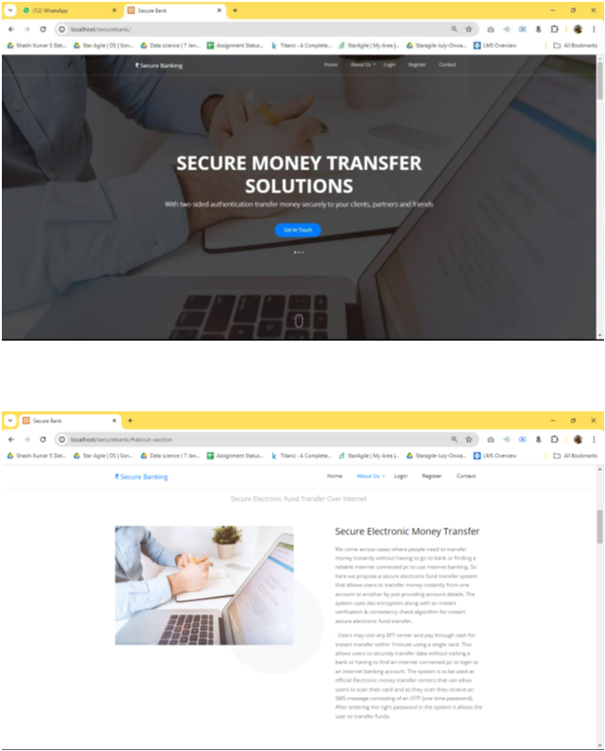

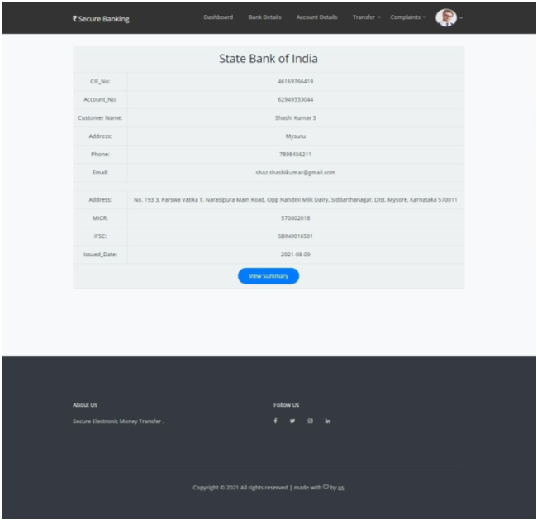

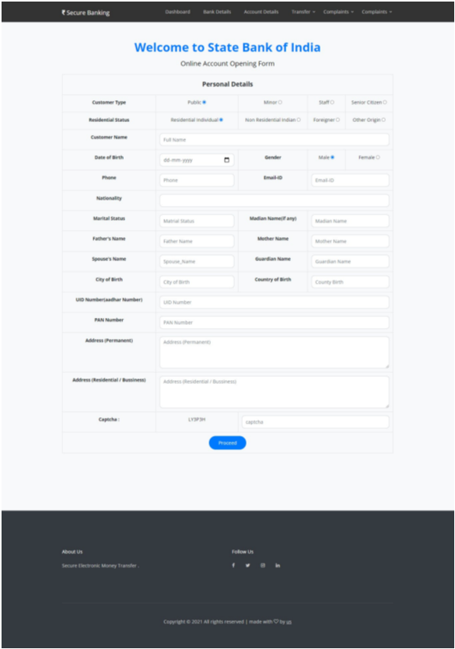

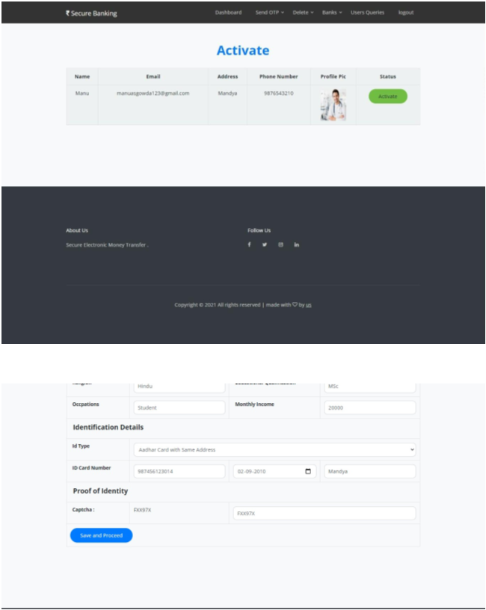

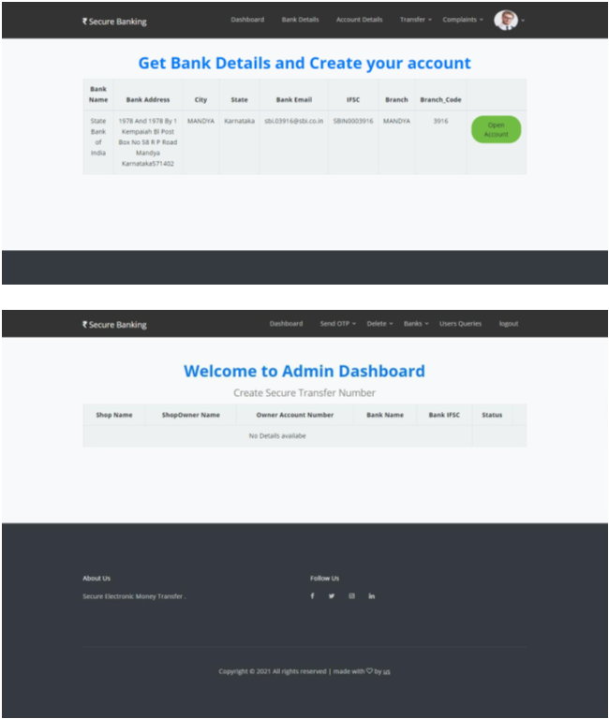

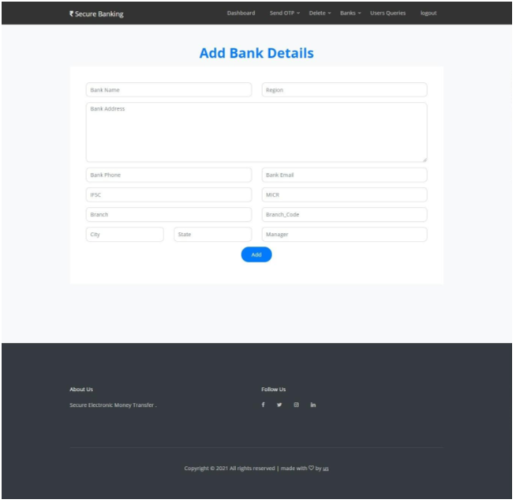

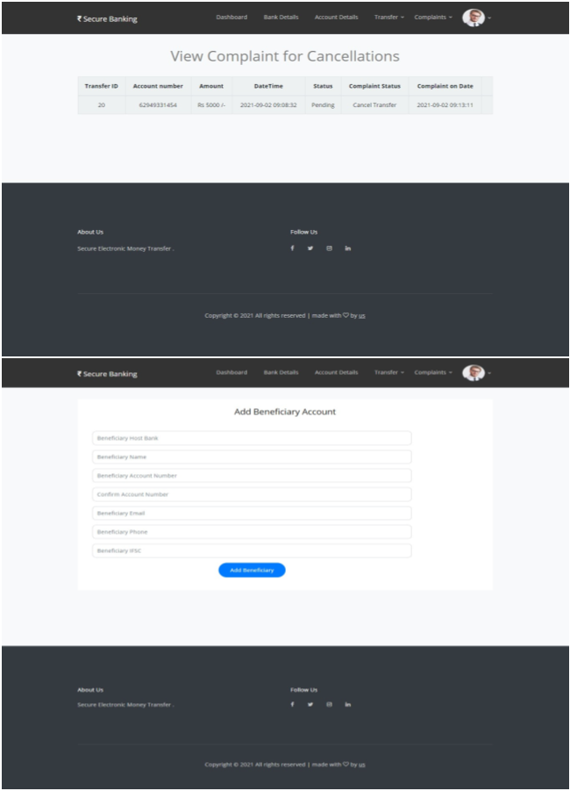

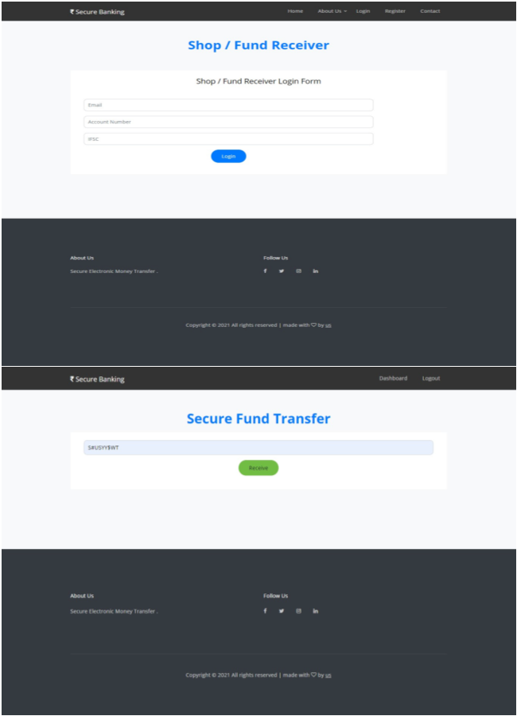

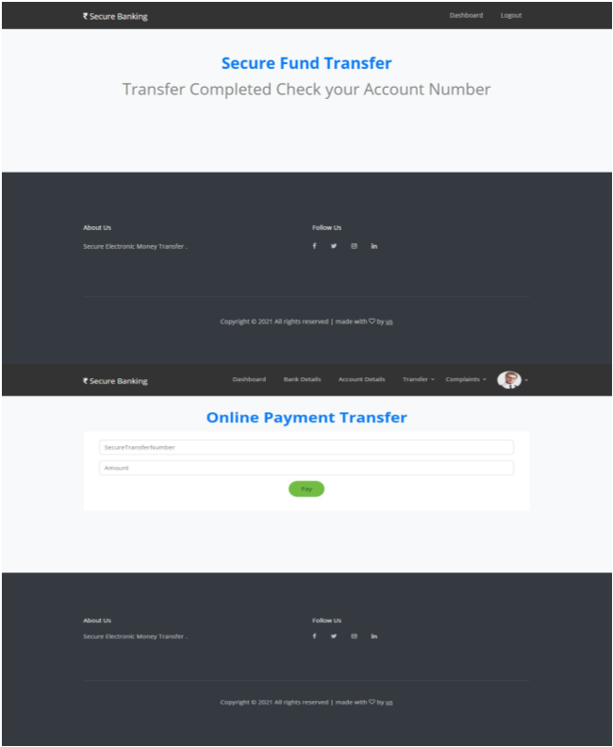

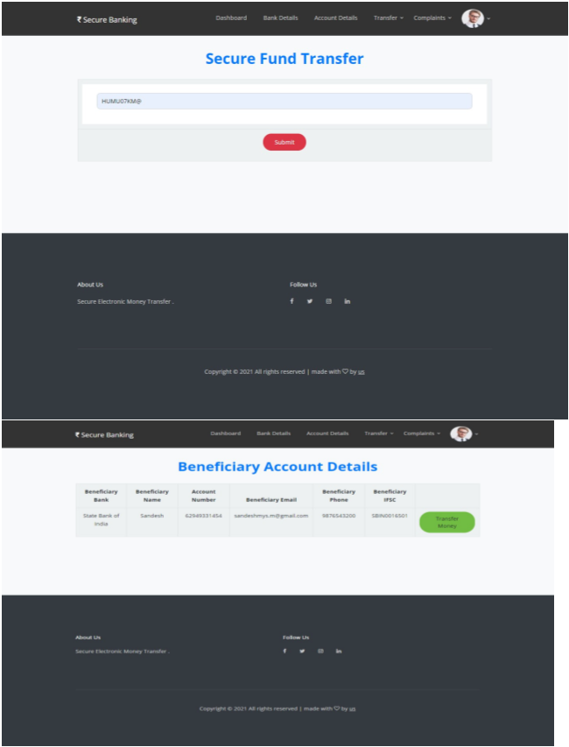

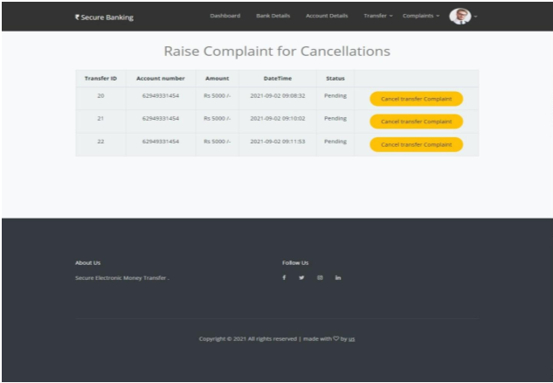

CONCLUSION

The undertaking pointed toward getting electronic asset moves over the web utilizing the Information Encryption Standard (DES) has effectively shown the practicality and viability of DES in scrambling exchange information. All through the venture, we have achieved the accompanying key targets:

Fruitful Execution of DES:

We carried out DES encryption to get the information communicated during electronic asset moves, guaranteeing that delicate data stays secret and shielded from unapproved access.

Approval of Safety efforts:

The situation was thoroughly tried to approve its security highlights, affirming that DES encryption successfully forestalls information breaks and keeps up with the honesty of exchange data.

Improved Security Conventions:

By incorporating DES with powerful verification instruments, we fortified the security conventions, lessening the gamble of extortion and unapproved exchanges.

Execution and Dependability:
The encryption cycle utilizing DES ended up being effective, supporting ongoing exchange handling without compromising execution.

Notwithstanding, the task additionally featured specific restrictions:
Weakness to Beast Power Assaults: The 56-cycle key length of DES is currently viewed as unreliable against present day computational abilities. Future upgrades ought to consider progressing to more hearty encryption norms like AES.

- Key Administration Difficulties:
Successful key administration rehearses are basic to keeping up with security. The task highlighted the requirement for secure key age, dissemination, and capacity.

FUTURE ENHANCEMENTS

Secure Electronic fund transfer over internet using standard algorithm is created to enhance the security and protections for fund transfer, here are our future enhancements:

- Adopt Advanced Encryption Standards: Moving to AES or other advanced encryption standards will enhance the security of electronic fund transfers.

- Add Extra Security Measures: Implementing additional security features, like multi-factor authentication and block chain technology, will strengthen the system and improve its overall resilience.

- Continual Security Audits: Regular security audits and updates are essential to address emerging threats and maintain the integrity of the software.

REFERENCE

[1] Agrawal, M., & Mishra, P. (2012). A comparative analysis of symmetric key encryption methods. International Journal on Computer Science and Engineering (IJSE), 4(5), 877-882.

[2] National Bureau of Standards. (1997). “Data Encryption Standard” (FIPS Pub. 46). Washington, DC: U.S. Government Printing Office.

[3] Zhu, D. (2002). Security measures in inter-bank fund transfers. “Journal of Electronic Commerce Research”, 3(1).

[4] SkLAVOS, N., & KOUPPAVL, O. (2002). Architectures and VLSI implementation of the DES and Rijndael proposals. “IEEE Transactions on Computers”, 51(21), 1454-1459.

[5] Meyer, C. H., Matyas, S. M., & Lennon, R. E. (1981). Criteria for cryptographic authentication in electronic funds transfer systems. IEEE.

Webiste:
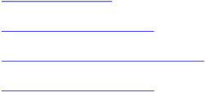
https://www.php.net/

https://www.researchgate.net
https://www.geeksforgeeks.org/mysql/ https://www.w3schools.com/

